NAME ADM NO. CLASS .

231/2
BIOLOGY (Theory)
March/April 2026
2 Hours
Marking scheme
- In certain experiment on fruit fly, the gene for long wings is dominant to the gene for vestigial wings. When long winged fruit flies were crossed with vestigial winged fruit flies, the eggs
laid were allowed to hatch to F1 generation. The F1 flies grew to maturity and were allowed to mate and their eggs hatched producing two sets of wings as shown below
- 68 had long wings
- 21 had vestigial wings
- 2 died

- What would have been the genotypes of the first parents where R stands for long wing?
(2marks)
    - Long wings RR;
    - Vestigial wings rr;
- Using a punnet square to represent the cross above, work out the F2 generation. (5 marks)
    - 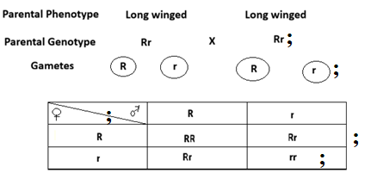
- What is the phenotypic ratio? (1mark)
- long wings; 1 Vestigial wings

- The setup below was used to demonstrate the products of expiration in a mouse. The set up was left undisturbed for 24 hours and observations were made.

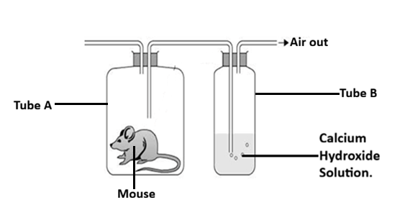

- (i) State the observation made in the tube B. (1mark)
Forms a white precipitate;
(ii) Account for the observation made in a (i) above. (2marks)
During expiration the mouse expel carbon (IV) oxide; which reacted with Calcium hydroxide to form insoluble Calcium carbonate which is a white precipitate;
(b) Explain the observation made in the test tube in a similar set up if we include a young
growing plant in the jar containing a mouse at the beginning of the experiment. (2marks)
The mouse will expel Carbon (IV) oxide during expiration which will be used by the plant to carry out photosynthesis; producing Oxygen gas which in turn will be used by the mouse for respiration; so, the calcium hydroxide solution remains clear;
(c) Name three gaseous exchange structures in higher plants. (3marks)
Stomata;
Lenticels;
Cuticles;

- The following diagram illustrates a setup to investigate a certain physiological process. The setup was left undisturbed for 10 minutes.
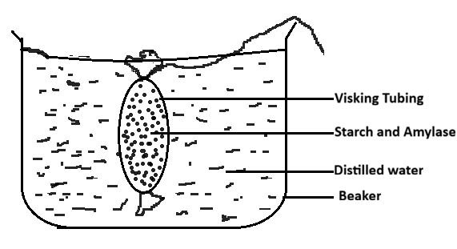
- Name the physiological process under investigation. (1mark)
Osmosis;
- State the observations made after 10 minutes. (2marks)
The visking tubing increases in size/ bulges/ enlarges;
- Account for the observation made. (3marks)
The amylase facilitates the breakdown of starch to glucose; glucose being osmotically active; water molecules move by osmosis from the beaker across the wall of visking tubing to the glucose solution leading to the bulging/increase in size/ enlargement; of the visking tubing;
- Explain why plant cells do not burst when placed in distilled water. (2marks)
The plant cell havea rigid cellulose cell wall; which creates an inward force (wall pressure) that prevent it from bursting;

- Examine photographs A and B carefully and use them to answer the questions that
follow.
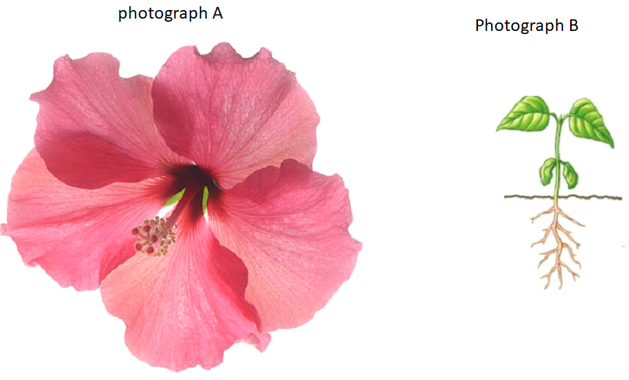
(b) i) State the type of germination exhibited in photograph B. (1mark)
Epigeal germination;
ii) Give a reason for your answer. (1mark)
Cotyledons are above the soil surface;
(c) using observable features only,classify the specimens into their respective classes from which the photographs were obtained.
their respective classes.
Photograph A (1mark)
Dicotyledonae; rej wrong spelling, small d
Reason (1mark)
5 floral parts/5 petals/ 5 stigma;
Photograph B (1mark)
Dicotyledonae; rej wrong spelling, small d
Reasons (3marks)
Leaves net veined;
Tap root system;
Leaves attached by petiole;

- Below are micrographs of tissues showing mitosis. Examine them and answer the questions that follows.

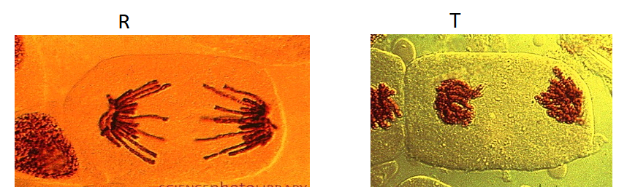
- i. Identify whether the micrographs were obtained was from plant or animal tissues. (1mark)
Plant tissue
ii. Give a reason for your answer in a) i above. (1mark)
It has got no centrioles/ absence of centrioles;
iii). Name the stages represented in micrograph R and T. (2marks)
R - Anaphase;
. T - Telophase;
- State two significance of mitosis to an organism. (2marks)
Growth of organism;
Repair of damaged tissues/Replacement of worn-out tissues;
Asexual reproduction;
Preservation of genetic information/Maintenance of chromosome number;

- Name two regions in higher plants where cells actively undergo mitosis. (2marks)

Root tip, Shoot tip, Cambium, Flower, Bud, Young leaf

- An experiment was carried out to determine the effect of drinking on excess amount of water on the flow of urine. A person drinks one litre of water and urine was collected at intervals of 15minutes. The results were as shown below:
Time in minutes | 0 | 15 | 30 | 45 | 60 | 75 | 90 | 105 | 120 | 135
Urine output ml/min | 1.6 | 1.6 | 1.6 | 5.4 | 9.0 | 9.0 | 7.6 | 3.0 | 0.8 | 0.8

(a) Plot a suitable graph to represent urine output against time. (6marks)



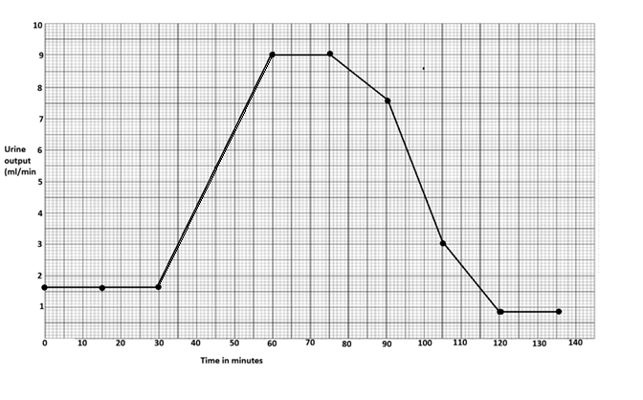 Labelling of axis – 2marks Scale - 2marks
Plotting – 1mark ( all the 10 plots must be there)
Smooth curve – 1mark ( must be hand drawn and smooth)
(b) State the amount of urine output at 50th minute. (1mark)
6.5ml/min + 0.2;
(b) Explain the rate of flow of urine between the following times;
(i) 30 and 60minutes. (3marks)
The rate of urine output increases with time; because a lot of water had been drunk, very little ADH produced; No reabsorption taking place;
(ii) 60 and 75minutes. (4marks)
The rate remains constant with time; Pituitary not stimulated to produce ADH;
Nephron, less permeable; No water being reabsorbed back to blood;
(iii) 75 and 135 minutes. (4marks)
The rate reduces with time; Little water remaining in blood; due to a lot of water lost through urine; No water being taken;

(c) Name two hormones responsible for regulation of relative amount of salts and water in man. (2marks)
ADH; Aldosterone;
- a) Explain the factors that determine energy requirement in human. (12marks)
- Basal metabolic rate;
This is the amount of energy required to maintain life;( the lowest level of energy production that is used to maintain life/the rate of energy expenditure during rest)
It varies from one individual to another and is affected by sex, body size, and age;
- Occupation;
Activities occurring everyday determines energy requirement; people doing heavy manual work like digging requires more energy than office worker;
- Age;
Children are more active and have more cell division because they are growing faster than adults; hence they require more energy than adult who as they grow older became less active and their energy demand decrease;
- Sex;
Most male are more muscular than female; they also do heavier work than female hence requires more energy than female;
- State of health;
A sick person requires more energy as the internal processes become more active;to fight infection and defend and repair the body; fever also causes more heat loss hence more energy to replace the heat lost;

- Describe aerobic respiration. (8marks)
Aerobic respiration is the process in which food substances such as glucose are broken down in the presence of oxygen in tissue cells to release energy, water and carbon (IV) oxide; It occurs in two phases
- Glycolysis;
- Kreb’s cycle;
Glycolysis:
It occurs in the cytoplasm of the cell;
It involves chemical breakdown of glucose into a 3-carbon compound called pyruvic acid;
In glycolysis, one molecule of glucose yields two molecules of ATP;
It does not require oxygen;
Kreb’s cycle:
Occur in the matrix of the mitochondria;
The pyruvic acid formed in glycolysis is further oxidized in a series of enzyme-controlled reactions that require oxygen to form carbon (IV) oxide, water and energy;
In kreb’s cycle one molecule of glucose yields 36 molecules of ATP;
(10marks - maximum 8Marks)

- Describe the nitrogen cycle. (20marks)
This is the cycling of nitrogen and its compounds in nature; plants absorb nitrogen in form of nitrates and then assimilate it into plant proteins; animals obtain this nitrogen in plant proteins through feeding on plants; when the animals die and decompose, they release the nitrogen in form of ammonia to the soil; free atmospheric nitrogen is converted into nitrates through a process known as nitrogen fixation; the process occurs in two ways: biological and non-biological; biological fixation of nitrogen is done by nitrogen-fixing bacteria; which are either free-living or symbiotic; symbiotic bacteria are of the genus Rhizobium; and are found in root nodules of leguminous plants (such as beans, pea, clover and alfalfa); the bacteria convert atmospheric nitrogen into ammonia; that is used directly by the leguminous plants to form nitrogen containing organic compounds (amino acids, nucleic acids, proteins); when plants and animals die they release ammonium compounds into the soil; which are then converted to nitrites; by nitrifying bacteria of genus Nitrosomonas and Nitrococcus (nitrite bacteria) and then to nitrates by Nitrobacter (nitrate) bacteria; free-living micro-organisms that fix nitrogen include putrefying/saprophytic bacteria; (such as Azotobacter spp, Clostridium and some algae such as Anabaena, Chlorella and Nostoc); the organisms fix nitrogen into ammonia by break down of protein material in dead organisms; the ammonia is converted to nitrites; then to nitrates; However, denitrifying bacteria (e.g. Pseudomonas denitrificans and Thiobacillus denitrificans); break down/reduce nitrates to nitrites, ammonium compounds and even gaseous nitrogen; a process known as denitrification; the process helps to release free nitrogen into the air for recycling; non-biological nitrogen fixing is carried out by lightning during thunderstorms; the lightning energy, causes atmospheric nitrogen and oxygen to combine forming oxides of nitrogen; which dissolve in rain water to form nitrous acid/nitric acid; that is washed down into the soil; the nitric acid formed reacts with other chemical compounds dissolved in soil water; to form nitrates; the nitrates are then utilized by plants; (Max.20 marks)

