NAME ADM NO. CLASS .

231/2
BIOLOGY (Theory)
March/April 2026
2 Hours
Instructions to candidates
  - Write your name and class in the spaces provided above.
  - Sign and write the date of examination in the spaces provided above.
  - This paper consists of two sections: A and B.
  - Answer ALL the questions in section A in the spaces provided.
  - In section B answer question 6 (compulsory) and either question 7 or question 8 in the spaces provided after question 8
  - Candidates should answer the questions in English.
  - Candidates should check the question paper to ascertain that all the pages are printed as indicated and no questions are missing.

- In certain experiment on fruit fly, the gene for long wings is dominant to the gene for vestigial wings. When long winged fruit flies were crossed with vestigial winged fruit flies, the eggs
laid were allowed to hatch to F1 generation. The F1 flies grew to maturity and were allowed to mate and their eggs hatched producing two sets of wings as shown below
- 68 had long wings
- 21 had vestigial wings
- 2 died

- What would have been the genotypes of the first parents where R stands for long wing?
(2marks)

- Using a punnet square to represent the cross above, work out the F2 generation. (5 marks)

- What is the phenotypic ratio? (1mark)

- The setup below was used to demonstrate the products of expiration in a mouse. The set up was left undisturbed for 24 hours and observations were made.

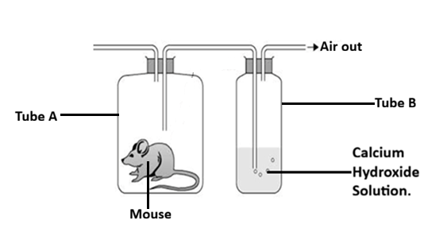

- (i) State the observation made in the tube B. (1mark)

(ii) Account for the observation made in a (i) above. (2marks)

(b) Explain the observation made in the test tube in a similar set up if we include a young
growing plant in the jar containing a mouse at the beginning of the experiment. (2marks)

(c) Name three gaseous exchange structures in higher plants. (3marks)

- The following diagram illustrates a setup to investigate a certain physiological process. The setup was left undisturbed for 10 minutes.
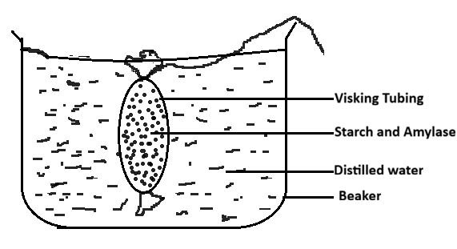
- Name the physiological process under investigation. (1mark)

- State the observations made after 10 minutes. (2marks)

- Account for the observation made. (3marks)

- Explain why plant cells do not burst when placed in distilled water. (2marks)

- Examine photographs A and B carefully and use them to answer the questions that
follow.
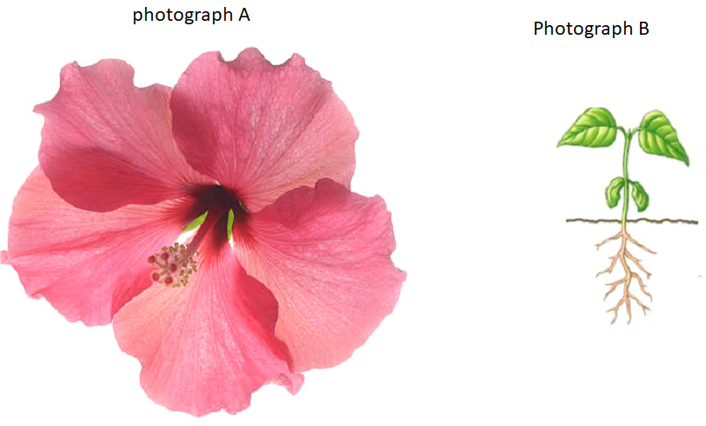
(b) i) State the type of germination exhibited in photograph B. (1mark)

ii) Give a reason for your answer. (1mark)

(c) using observable features only,classify the specimens into their respective classes from which the photographs were obtained.
their respective classes.
Photograph A (1mark)

Reason (1mark)

Photograph B (1mark)

Reasons (3marks)

- Below are micrographs of tissues showing mitosis. Examine them and answer the questions that follows.
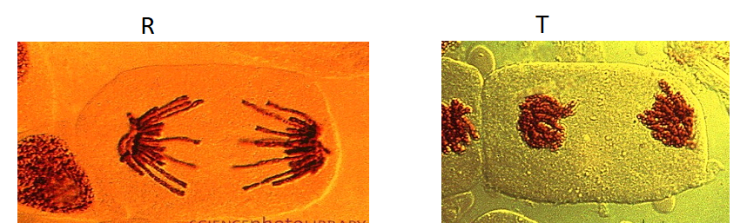
- i. Identify whether the micrographs were obtained was from plant or animal tissues. (1mark)

ii. Give a reason for your answer in a) i above. (1mark)

iii). Name the stages represented in micrograph R and T. (2marks)
R -
. T -
- State two significance of mitosis to an organism. (2marks)

- Name two regions in higher plants where cells actively undergo mitosis. (2marks)

SECTION B

answer question 6 (compulsory) and either question 7 or question 8 in the spaces provided after question 8

- An experiment was carried out to determine the effect of drinking on excess amount of water on the flow of urine. A person drinks one litre of water and urine was collected at intervals of 15minutes. The results were as shown below:
Time in minutes | 0 | 15 | 30 | 45 | 60 | 75 | 90 | 105 | 120 | 135
Urine output ml/min | 1.6 | 1.6 | 1.6 | 5.4 | 9.0 | 9.0 | 7.6 | 3.0 | 0.8 | 0.8

(a) Plot a suitable graph to represent urine output agaist time. (6marks)



(b) State the amount of urine output at 50th minute. (1mark)

(b) Explain the rate of flow of urine between the following times;
(i) 30 and 60minutes. (3marks)

(ii) 60 and 75minutes. (4marks)

(iii) 75 and 135 minutes. (4marks)

(c) Name two hormones responsible for regulation of relative amount of salts and water in man. (2marks)

- a) Explain the factors that determine energy requirement in human. (12marks)
- Describe aerobic respiration. (8marks)
- Describe the nitrogen cycle. (20marks)

………………………………………………………………………………………………………………………………………………………………………………………………………………………………………………………………………………………………………………………………………………………………………………………………………………………………………………………………………………………………………………………………………………………………………………………………………………………………………………..………………………………………………………………………………………………………………………………………………………………………………………………………………………………………………………………………………………………………………………………………………………………………………………………………………………………………………………………………………………………………………………………………………………………………………………………………………………………………………..
………………………………………………………………………………………………………………………………………………………………………………………………………………………………………………………………………………………………………………………………………………………………………………………………………………………………………………………………………………………………………………………………………………………………………………………………………………………………………………..
………………………………………………………………………………………………………………………………………………………………………………………………………………………………………………………………………………………………………………………………………………………………………………………………………………………………………………………………………………………………………………………………………………………………………………………………………………………………………………………………………………………………………………………………………………………………………………………………………………………………………………………………………………………………………………………………………………………………………………………………………………………………………………………………………………………………………………………………………………………………………………………………………………………………………………………………………………………………..
………………………………………………………………………………………………………………………………………………………………………………………………………………………………………………………………………………………………………………………………………………………………………………………………………………………………………………………………………………………………………………………………………………………………………………………………………………………………………………

