NAME_______________________________________ADM NO._____________CLASS______

231/3
BIOLOGY (Theory)
March/April 2026
1 3/4 Hours
KENYA CERTIFICATE OF SECONDARY EDUCATION
MARKING SCHEME

Answer all the questions in the spaces provided.

- You are provided with a young seedling of a plant, examine it and answer the questions that follows.
(a) Draw and label any 3 parts of the specimen given. (5marks)
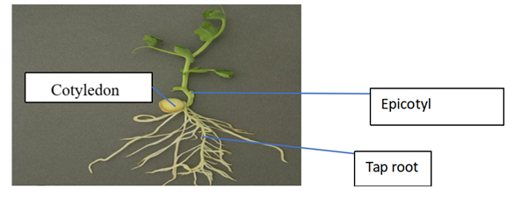

Drawing 2marks
Continous outline
Label line to touch the specific structure rej arrows for label line
Labelling 3 marks
acc Any other correctly labelled part
(b) using observable features only, state the class to which the plant belongs to. (1mark)
Dicotyledonae;
(c) Give the reason for your answer in (a) above. (3marks)
Has two cotyledons;
Has a tap root system;
Network venation on the leaves;
(d) Name the type of germination exhibited by the seedling. Give a reason for your answer. (3marks)
Hypogeal germination; because the epicotyl is the first to elongate pulling the plumule out of the cotyledons; and out of the ground leaving the cotyledons in the soil;
(e) What is the significance of the food stored in the cotyledons. (2mark)
Reserve food for growth; and development of the embryo;

2.The photographs below represents parasitic interrelationship. Study them and answer the questions that follows.
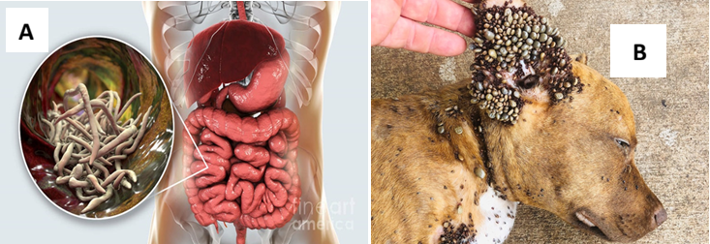

- Identify the type of parasite represented by Photograph A and B. (2marks)
A – endoparasite;
B- ectoparasite;
- State two benefits the parasite in B gets from the host. (2marks)
- Food/ nutrients;
- Shelter;
- How is parasite A transmitted to man. (2marks)
- Through contaminated food and water with faeces or with eggs of adult female;
- From faeces to mouth by hands especially in children;
- State two effects of the parasite in A to the Host. (2marks)
- Cause irritation of the trachea that lead to lung damage and infection with other diseases;
- Leads to malnutrition as most of the food is consumed by the parasite;
- Heavy infestation can lead to blockage of the intestines where victims develop round stomachs;
- The worm may also enter bile duct, pancreatic duct and appendix causing further complications;
- Name two control measures to prevent infection with parasite A. (2marks)
- Proper sanitary disposal methods;
- High standards of personal hygiene such as washing hands after a visit to the toilet;
- Hygienic handling and cleaning of fruits and vegetables;
- Boiling drinking water;
- Treating infected people;

- State four ways in which parasite A is adapted to stay on the host body. (4 marks)
- Lay many eggs to increase chances of survival when some is destroyed;
- Eggs have protective shell to survive harsh environmental conditions;
- Has a thick elastic cuticle to protect it against the digestive enzymes of the host enabling it to survive the digestive system;
- Has tissues tolerant to low oxygen concentration characteristic of the gut;
- Has a muscular pharynx through which it sucks digestive food from the host’s intestine into its own gut;
Specimen D is a young leaf of tradescantia

3. You are provided with a specimen labelled D, which is part of a plant.
(a) (i) Using external features only, identify the organ of the plant. (1mark)
Leaf;
(ii) Give four reasons for your answer in a (i) above. (4 marks)
Has Leaf blade / lamina;
Presence of petiole / leaf stalk;
Presence of veins rej. Venation;
Has mid-rib;
Any three correct
(b) i) Peel off the epidermis of the lower surface of the specimen. Mount a portion of the epidermis in a drop of water on a microscope slide. Cover with a cover slip, observe the specimen under medium power objective lens and count the number of stomata in the field of view. Record the number of stomata in the upper epidermis in the table 1 below.

(ii)Repeat the procedure above using the epidermis from the upper surface. Record the number of stomata in the upper epidermis in the table 1 below.

Number of stomata
Upper epidermis | Lower epidermis
8-11 (must be lower than that of lower epidermis.) | 13/16 (must be higher than that of upper epidermis.)
(2mark)
(d) Record the following from the microscope you used to count the stomata.
(i) Magnification of eyepiece lens. (1mark)
Magnification of eyepiece lens x 10;

(ii) Magnification of objective lens used. (1mark)

Magnification of objective lens used x10;

(iii) From the data in d (i) and (ii) above, calculate the total magnification. Show your working. (2marks)

Total magnification. = Mg eyepiece x Mg Objective;
10 x 10 = X100;

(e) Account for the difference in number of stomata on each surface of the specimen.. (2marks)
Upper epidermis has fewer stomata to reduce transpiration / water loss / rate of
evaporation/ stomata exposed to direct sunlight;
Lower epidermis – more to increase rate of gaseous exchange / allow more gaseous exchange/ more stomata away from the sun to reduce rate of transpiration;

