NAME_______________________________________ADM NO._____________CLASS______

231/3
BIOLOGY (Theory)
March/April 2026
1 3/4 Hours
KENYA CERTIFICATE OF SECONDARY EDUCATION

Answer all the questions in the spaces provided.

- You are provided with a young seedling of a plant, examine it and answer the questions that follows.
(a) Draw and label any 3 parts of the specimen given. (5marks)

(b) Using observable features only, state the class to which the plant belongs to. (1mark)

(c) Give the reason for your answer in (a) above. (3marks)

(d) Name the type of germination exhibited by the seedling. Give a reason for your answer. (3marks)

(e) What is the significance of the food stored in the cotyledons. (2mark)

2.The photographs below represents parasitic interrelationship. Study them and answer the questions that
follows.
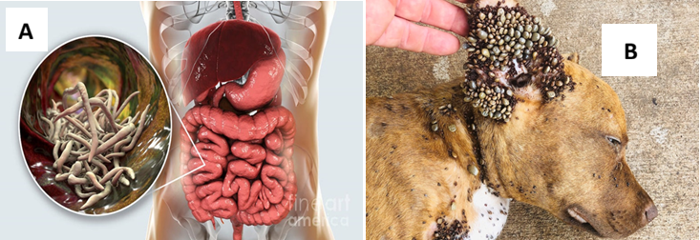

- Identify the type of parasite represented by Photograph A and B. (2marks)
A –
B-
- State two benefits the parasite in B gets from the host. (2marks)

- How is parasite A transmitted to man. (2marks)

- State two effects of the parasite in A to the Host. (2marks)

- Name two control measures to prevent infection with parasite A. (2marks)

- State four ways in which parasite A is adapted to stay on the host body. (4 marks)

3. You are provided with a specimen labelled D, which is part of a plant.
(a) (i) Using external features only, identify the organ of the plant. (1mark)

(ii) Give four reasons for your answer in a (i) above. (4 marks)

(b) Peel off the epidermis of the lower surface of the specimen. Mount a portion of the epidermis in a
drop of water on a microscope slide. Cover with a cover slip, observe the specimen under medium
power objective lens and count the number of stomata in the field of view. Record the number of
stomata in the upper epidermis in the table below.

(c) Repeat the procedure above using the epidermis from the upper surface. Record the number of stomata
in the upper epidermis in the table below.

Number of stomata
Upper epidermis | Lower epidermis
(2mark)
(d) Record the following from the microscope you used to count the stomata.
(i) Magnification of eyepiece lens. (1mark)

(ii) Magnification of objective lens used. (1mark)

(iii) From the data in d (i) and (ii) above, calculate the total magnification. Show your
working. (2marks)

(e) Account for the difference in number of stomata on each surface of the specimen. (2marks)

