MURANGA SOUTH SUB COUNTY
CHEMISTRY PAPER 2 END TERM 1 2026
NAME: …………………………………………………… CLASS: ……………. ADM NO: ……….
- The set up below is used to prepare hydrogen sulphide gas.

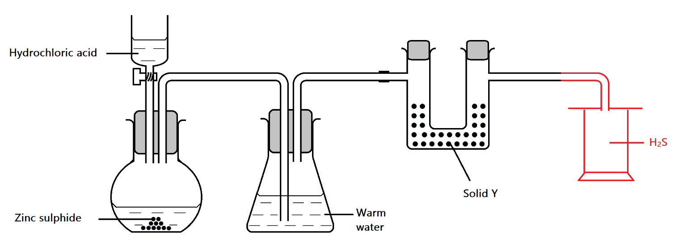
- i) Complete the diagram to show how dry hydrogen sulphide can be collected. ( 1 mk)
Downward delivery
ii) Write an equation for the reaction taking place in the round bottomed flask. (1mk)

ZnS_{(s)} + 2Hcl_{(aq)} ZnCl_{2(aq)} + H₂S_{(g)}

iii) What precaution is necessary when preparing hydrogen sulphide. (1mk)
Should be done in a fume chamber/open air

iv) Name solid Y. ( 1 mk)
Anhydrous Calcium chloride/Calcium oxide

v) State the function of warm water in the conical flask. (1mk)
To absorb acid vapour Hcl_{(g)}

- State and explain the observations that would be made when hydrogen sulphide gas is bubbled through dilute Nitric (V) acid in boiling tube. (2 mks)
Brown fumes and yellow solid formed. Hydrogen sulphide is oxidized to yellow solid Sulphur while Nitric (V) acid is reduced to Nitrogen)IV) oxide gas which is brown.
- Using an equation, state the observation made when hydrogen sulphide burns in a limited supply of oxygen. (2 mks)
H₂S_{(g)} + O_{2(g)} 2S_{(s)} + 2H₂O_{(l)} , yellow deposit, A colourless liquid
- The flow chart below are some reactions in organic chemistry. Study the flow chart and answer the questions that follow.
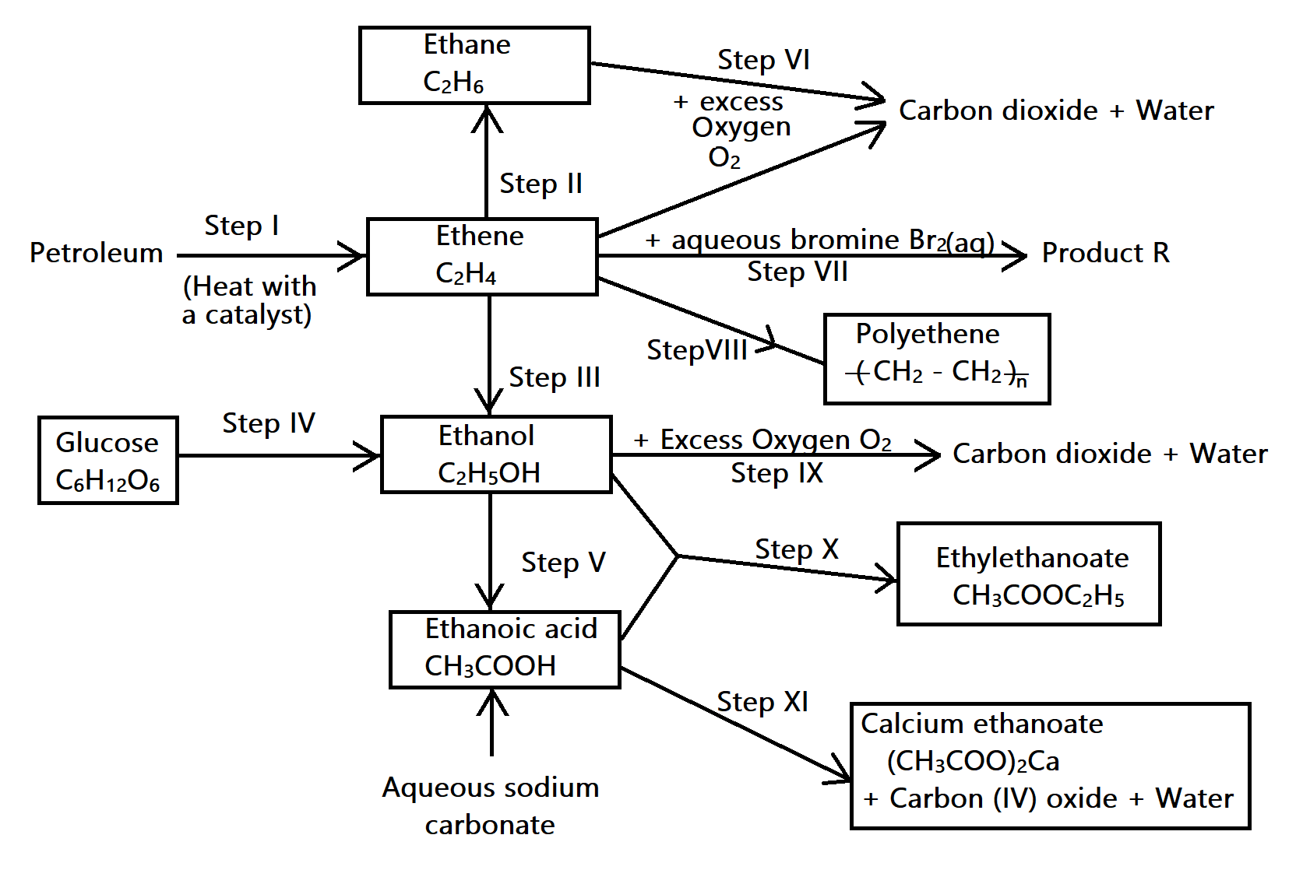

- Name the process in step I (1mk)
Cracking of alkanes
- State the conditions and reagents for the reaction in step II. (2mk)
Condition – Nickel catalyst, Temperature of 150 – 250ºC each condition @ 1/2
Reagent - Hydrogen
- (i) Name the reaction in step III. (1 mk)
Hydration
- Suggest a reagent that could be used in this reaction. ( 1mk)
Steam
- Give two conditions that would be necessary for this reaction to occur. (1mk)
- Phosphoric (V) acid catalyst
- Temperature of 300ºC
- Pressure of 60-70 atmospheres
(d) Describe step IV under the following headings:
i) Name of reaction (1 mk)
Fermentation
ii) Conditions (1 mk)
Temperature between 25-35ºC (accept any value within the range)
Absence of oxygen
iii) Equation (1mk)
C₆H₁₂O₆ 2C₂H₅OH+2CO₂ (don’t penalize for state symbols).
(e) (i) With reference to steps V and X, complete the table below. (2mks)
Step | Name of reaction
V | oxidation
X | esterification

(f) Write equations for the reactions in:
i) Step V – C₂H₅OH + 2[O] CH₃COOH+H₂O (1mk)
ii) Step VII – C₂H₄ + Br₂ CHBrCHBr (1mk)
iii) Step X – C₂H₅OH + CH₃COOH CH₃COOC₂H₅+H₂O (1mk)
(g) Name the type of reaction in each of the reactions marked:
i) Step VII – Addition/halogenation ( ½ mk)
ii) Step IX – Combustion ½ mk)
iii) Step XI - Displacement ( ½ mk)
(h) State one use of the product in step VIII. ( ½ mk)
making polythene bags (II) lining of jackets (III) insulators
3. a) The grid below represents part of a periodic table. Study it and answer the questions that follow. The letters do not represent the actual symbols of elements.
S |  |  |  | R | E |  | X
 |  |  |  |  |  |  |  | V
Q | Z |  |  |  |  | M
 |  |  |  |  |  |  | T

- Identify the most reactive non-metal. ( 1mk)
X
- Which of the metals is most reactive? Explain. ( 2mks)
Q – Largest atomic radius hence electrons are readily lost
- What name is given to the family of elements to which elements X and T belong. (1mk)

Halogens
- Give reasons for the following
- Atomic radius of Q is bigger than that of M. M has more protons than Q // M has higher nuclear charge (1mk)
- Atomic radius of Q is greater than that of S. (1mk)
Q has more energy levels than S
- Give an element which does not form compounds under ideal conditions. Explain. (2mks)
C, its stable (completely full outer energy level.

- Give the formula of the compound formed between element R and Z. ( 1 mk)
Z₂R//
b) Study the table below and answer the questions that follow.
Substance | A | B | C | D | E | F
M.P (ºC) | 801 | 119/113 | 139 | -5 | -101 | 1356
B.P (ºC) | 1410 | 445 | 457 | 54 | -36 | 2860
Electrical conductivity (solid) | Poor | Poor | Good | Poor | Poor | Poor
Electrical conductivity (liquid) | Good | Poor | Good | Poor | Poor | Poor
- Identify a substance with;
- Giant metallic structure. ( ½ mk)
C
- Simple molecular structure ( ½ mk)
D
E any of the two,award half a mark
- Suggest a reason why substance B has two melting points. (1mk)
Exhibits allotropy.

- Substance A and C conduct electric current in the liquid state. State how the two substances differ as conductors of electric current. (2mks)
A conducts due to the presence of mobile ions in liquid state while B conducts due to the presence of delocalized electrons.
4. a) The solubility of salt X at various temperatures is as shown in the date given below.
Temperature (ºC) | 0 | 20 | 40 | 60 | 80 | 100
Solubility (g/100g of water) | 10 | 15 | 26 | 40 | 63 | 100

- Using a suitable scale draw a solubility curve of salt X on the grid provided below. (3mks)
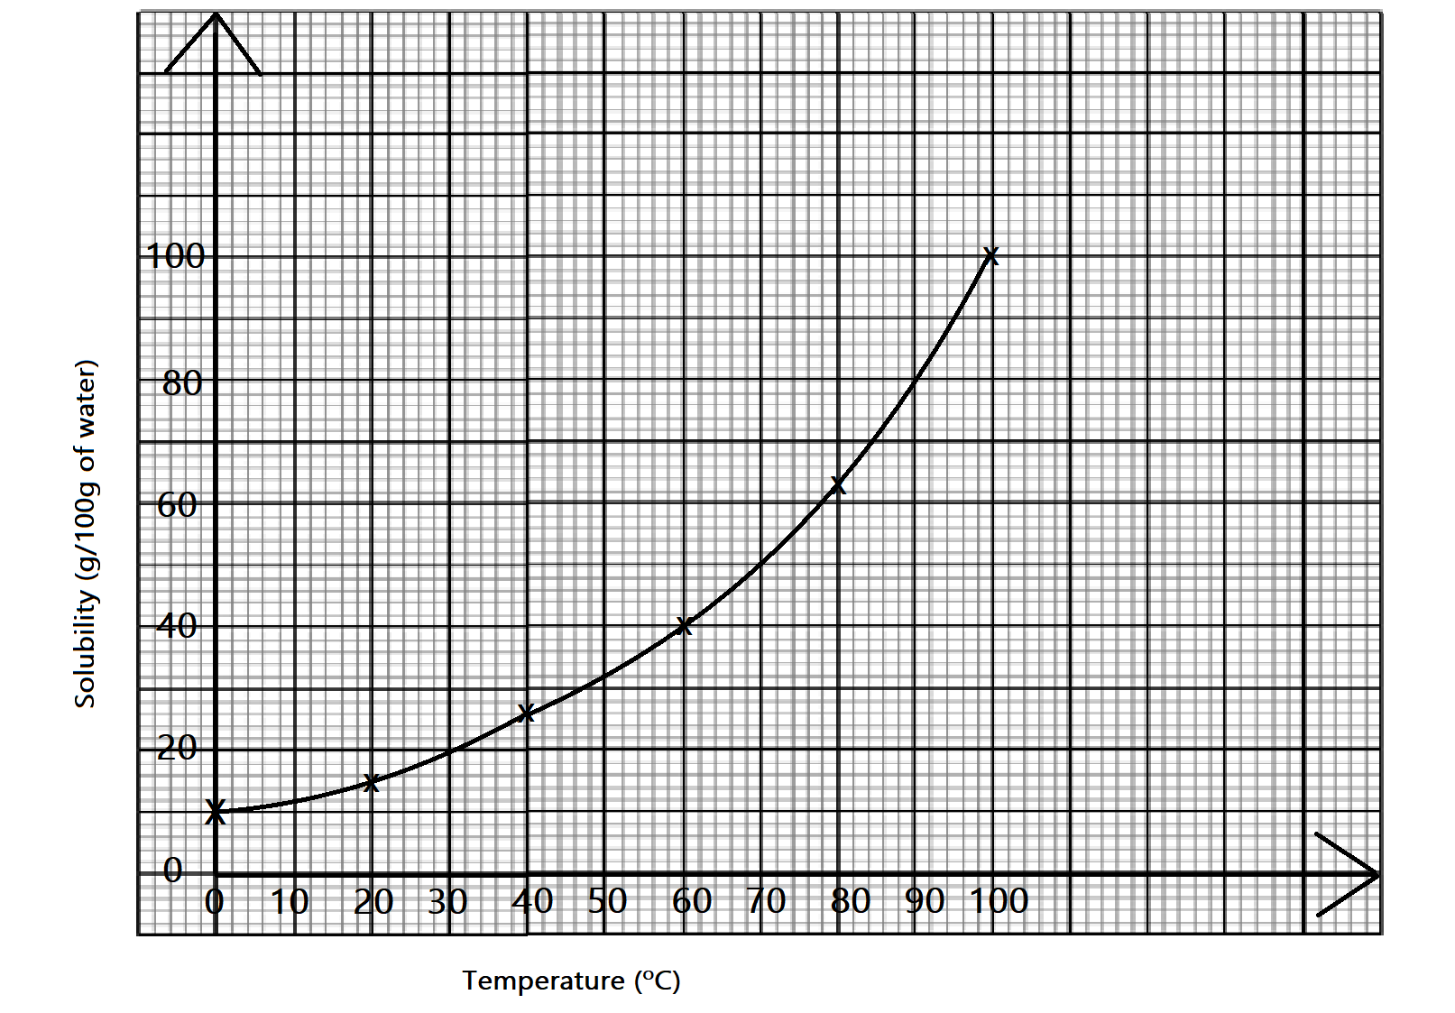
- A solution containing 20g of salt X in 100g of water was cooled from 50ºC.
- At what temperature will crystals of salt X first form? (1mk)
30+2ºC
- Determine the mass of X that crystallizes if the solution is cooled to 12ºC. (2mks)
20-12=8g
b) Use the information below on solubility to answer questions that follow.

Salt | Solubility g/100g of water
Salt | 80ºC | 20ºC
KCLO₃ | 55 | 12
Na₂CO₃ | 80 | 36
A mixture containing 30g of potassium chlorate and 30g of sodium carbonate in 100g of water at 80ºC was cooled to 20ºC. Some crystals were formed.
- Which of the two salts crystallized. (1mk)
KclO₃
- Name the method that can be used to obtain the crystals. (1mk)
Fractional crystallization
- State the salt that would be unsaturated at 20ºC. (1mk)
Na₂CO₃
- Magnesium powder was added to the mixture shown in beaker (a) and sodium carbonate added to the mixture in beaker (b). Study the set ups and answer the questions that follow.
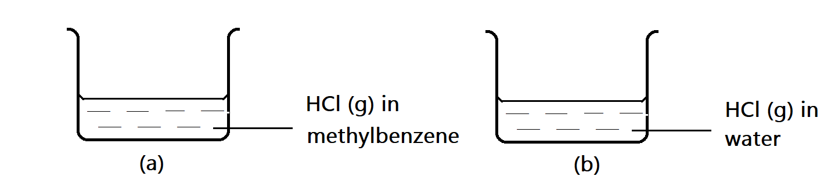

- In which beaker will there be effervescence. 1mk)
(b)
- Explain why there is no reaction in the other beaker. (1mk)
Hcl in methylbenzene doesn’t ionize but remains in molecular form
5. In an experiment to determine the heat of displacement of copper by Iron, 50cm³ of 0.2M Copper (II) sulphate solution was reacted with excess iron filings and following results obtained.
Initial temperature of copper (II) sulphate = 25.0ºC
Final temperature of copper (II) sulphate = 31.0ºC
Mass of iron fillings used =1.0g
(Density of solution 1.0g/cm³, specific heat capacity 4.2Jg⁻¹K⁻¹
Calculate
- Temperature change ( ½ mk)
31-25=6º
- Mass of solution ( ½ mk)
Mass = density x volume= 50x1=50g
- Heat evolved during reaction ( 2mks)
H=Mc ∆T
= 50 x 4.2 x 6 = 1260J

- Molar heat of displacement in kilojoules mol⁻¹ (2mks)
Moles of CU²⁺ displaced = 50/1000 x 0.2=0.01moles
0.01moles 1260J
1 mole 126000J/mol -126KJ/mol

- Write the thermochemical equation for reaction above. (1mk)
Fe_{(s)} + CUSO_{4(aq)} FeSO_{4(aq)} +CU_{(s)} ∆H= -126kj/mol
- Explain why excess iron filings were used. (1mk)
Ensure all the CU²⁺ are displaced
- Draw an energy level diagram for the above reaction. (2mks)
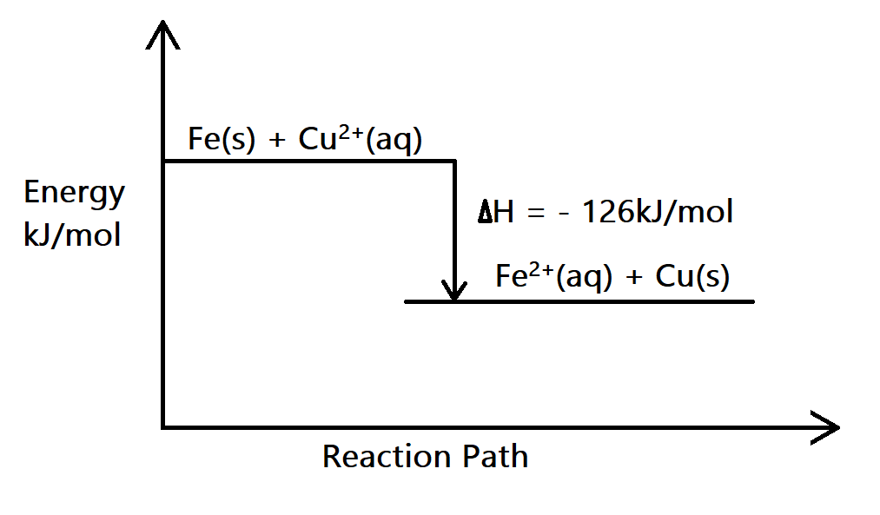
b) i) What is a fuel? (1mk)
A substance that produces energy when it undergoes a chemical or nuclear reaction
ii) Give two factors to consider when choosing a fuel for use. (2mks)
- Cost 3. Any other
- Availability
6. In an experiment carbon (IV) oxide was passed over heated charcoal and the gas produced collected as shown in the diagram below.
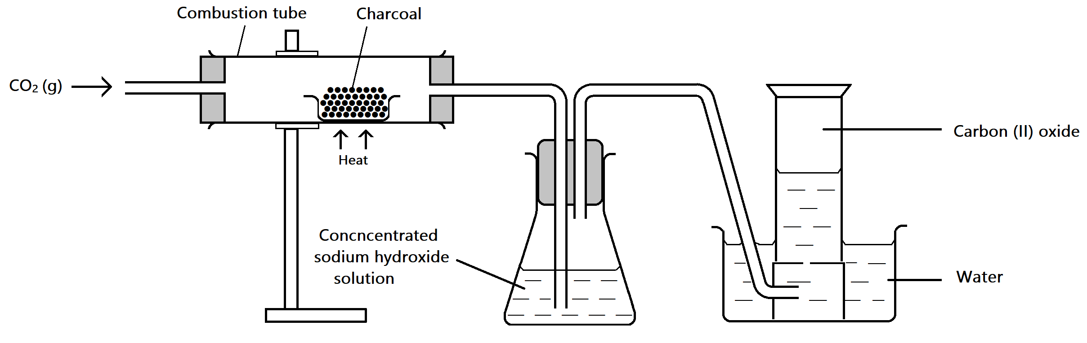

- i) Write an equation for the reaction that took place in the combustion tube. (1mk)

C_{(s)} + CO_{(g)} 2CO_{(g)}

- Name another chemical substance that can be used instead of sodium hydroxide. (1mk)

Potassium hydroxide

- Describe a simple chemical test that can be used to distinguish between carbon (II) oxide and carbon (IV) oxide. (2mks)
Bubble the 2 gases through lime water separately, CO₂ forms white ppt while CO doesn’t form white ppt
- State one use of carbon (II) oxide. (1mk)
As a reducing agent
As fuel

- In another experiment to synthesize sodium carbonate in the lab students passed carbon (IV) oxide and ammonia gas into brine as shown in the flow diagram below. Use it to answer the questions that follow.
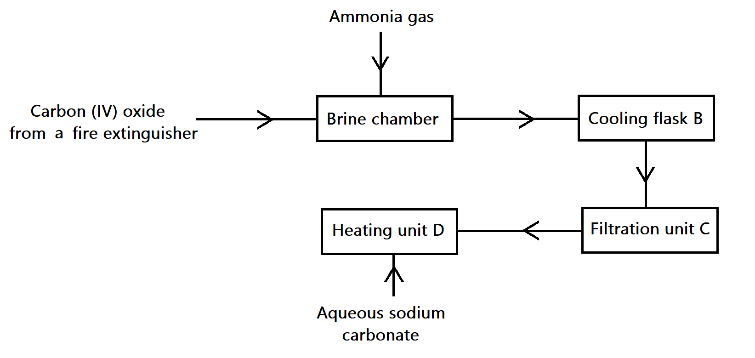
- Why is the mixture obtained in chamber A cooled in chamber B. (2mks)
The reaction is highly exothermic
- Give a reason why it is difficult to synthesize potassium carbonate by the same method. (1mk).
Potassium hydrogen carbonate obtained at the solvay tower is highly soluble making it impossible to separate from ammonium chloride.
- State two properties of carbon (IV) oxide that enables it to be used in the fire extinguishers. (2mks)
- Denser than air
- Doesn’t burn nor support combustion
7. The diagram below show an incomplete set-up for apparatus used in preparation and collection of dry ammonia gas.
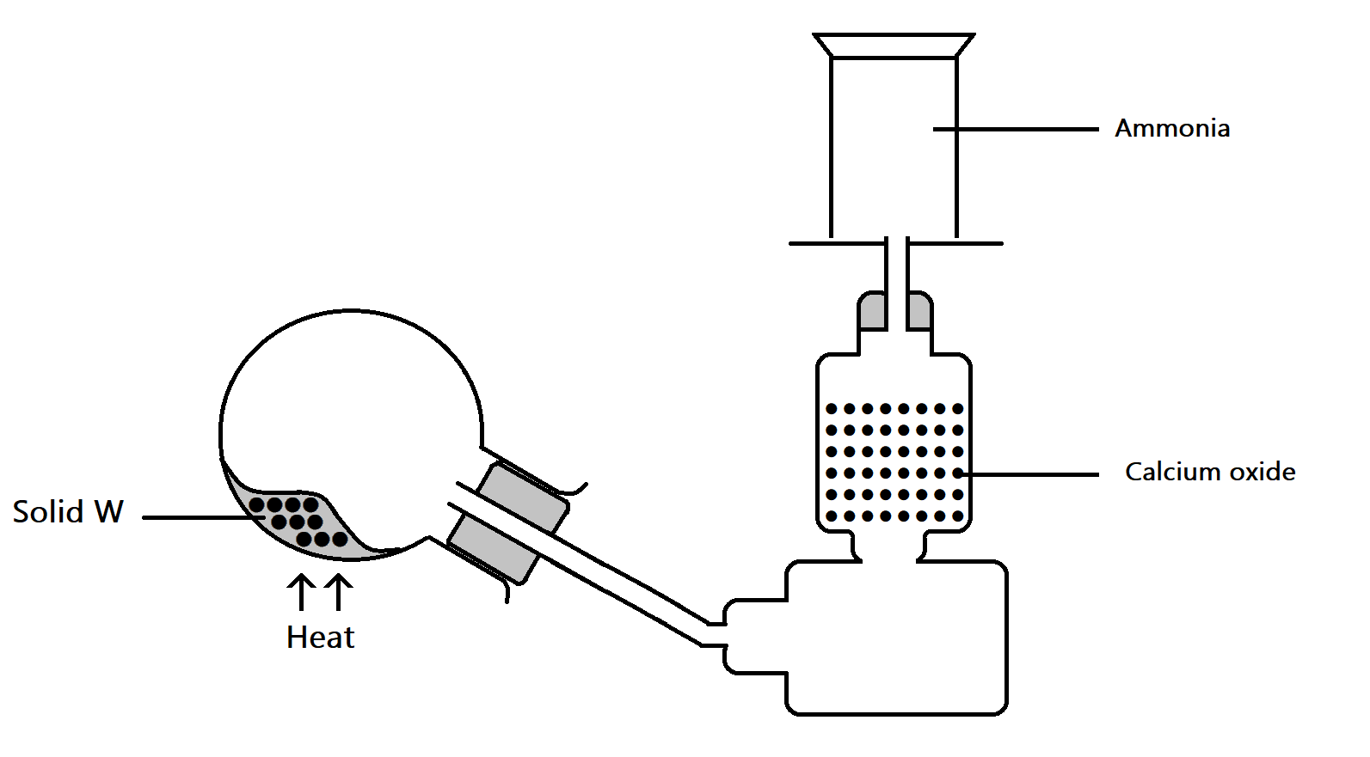

- i) Complete the diagram to show how a dry sample of ammonia can be obtained. (3mks)

ii) Name appropriate substance that can be used as solid X. (1mk)

Mixture of Ca(OH)₂ and NH₄Cl
- Write equation of reaction that produces ammonia in the above experiment. (1mk)
2NH₄Cl_{(s)} + Ca(OH)_{2(s)} 2NH_{3(g)} + CaCl_{2(aq)} + 2H₂O_{(l)}

- In the space provided below draw a diagram to show how a sample of aqueous ammonia can be prepared. (2mks)

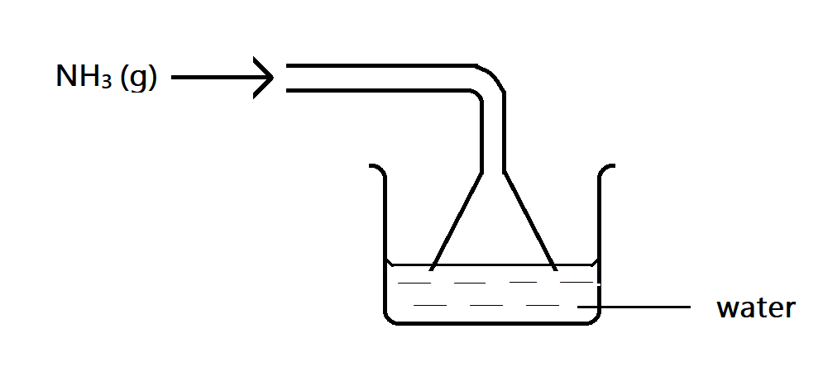
- Use dot(.) and cross(x) diagram to show bonding in (2mks)
- Ammonia molecule
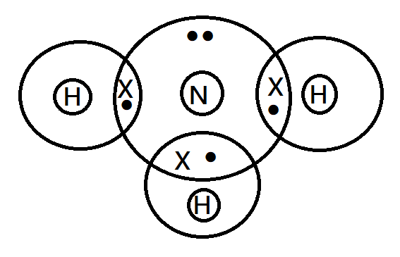
- Ammonium ion
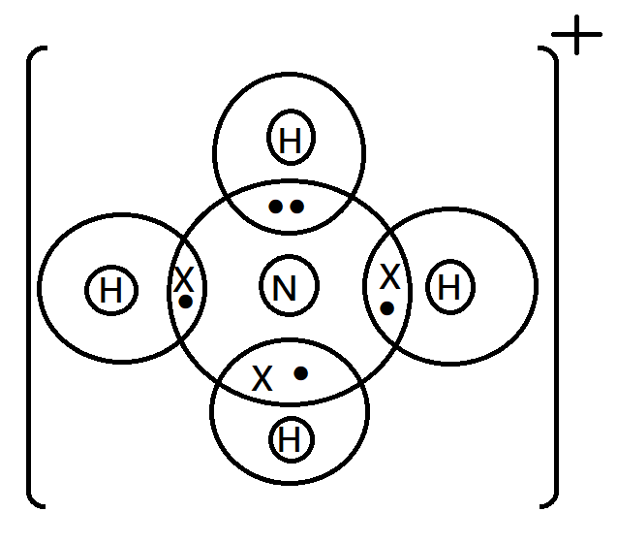
- i) State and explain the observations that would be made when excess ammonia gas is bubbled through a solution Iron (II) sulphate. (2mks)

Green ppt insoluble in excess

- Write ionic equation for reaction that occurs in d(i) above. (1mk)

Fe²⁺_{(aq)} + 2OH⁻_{(aq)} Fe(OH)_{2(s)}

LAST PRINTED PAGE.

