NAME………………………………………………INDEX NO:.…………ADM NO………………
SCHOOL…………………………………………SIGNATURE……...….…. DATE…....…………

233/2
CHEMISTRY PAPER 2 (THEORY) ADM NO ……………....
TIME: 2 HOURS
MARCH/APRIL 2026
FORM 4
Kenya Certificate of Secondary Education (K.C.S.E)
INSTRUCTIONS TO CANDIDATES
- Write your name and index in the spaces provided.
- Sign and write the date the examination is done.
- Answer all the questions in the spaces provided.
- Non-programmable silent electronic calculators and KNEC mathematical tables may be used.
- ALL workings MUST be clearly shown where necessary.
- This paper contains 12 printed pages.
- Candidates should check the question paper to ascertain that all pages are printed as indicated and that no question is missing.
- Candidates should answer questions in English.
For Examiner’s Use Only
Question | Maximum Score | Candidate’s Score
1 | 9
2 | 14
3 | 13
4 | 11
5 | 12
6 | 9
7 | 12
Total Score | 80
- The set up below is used to prepare hydrogen sulphide gas.
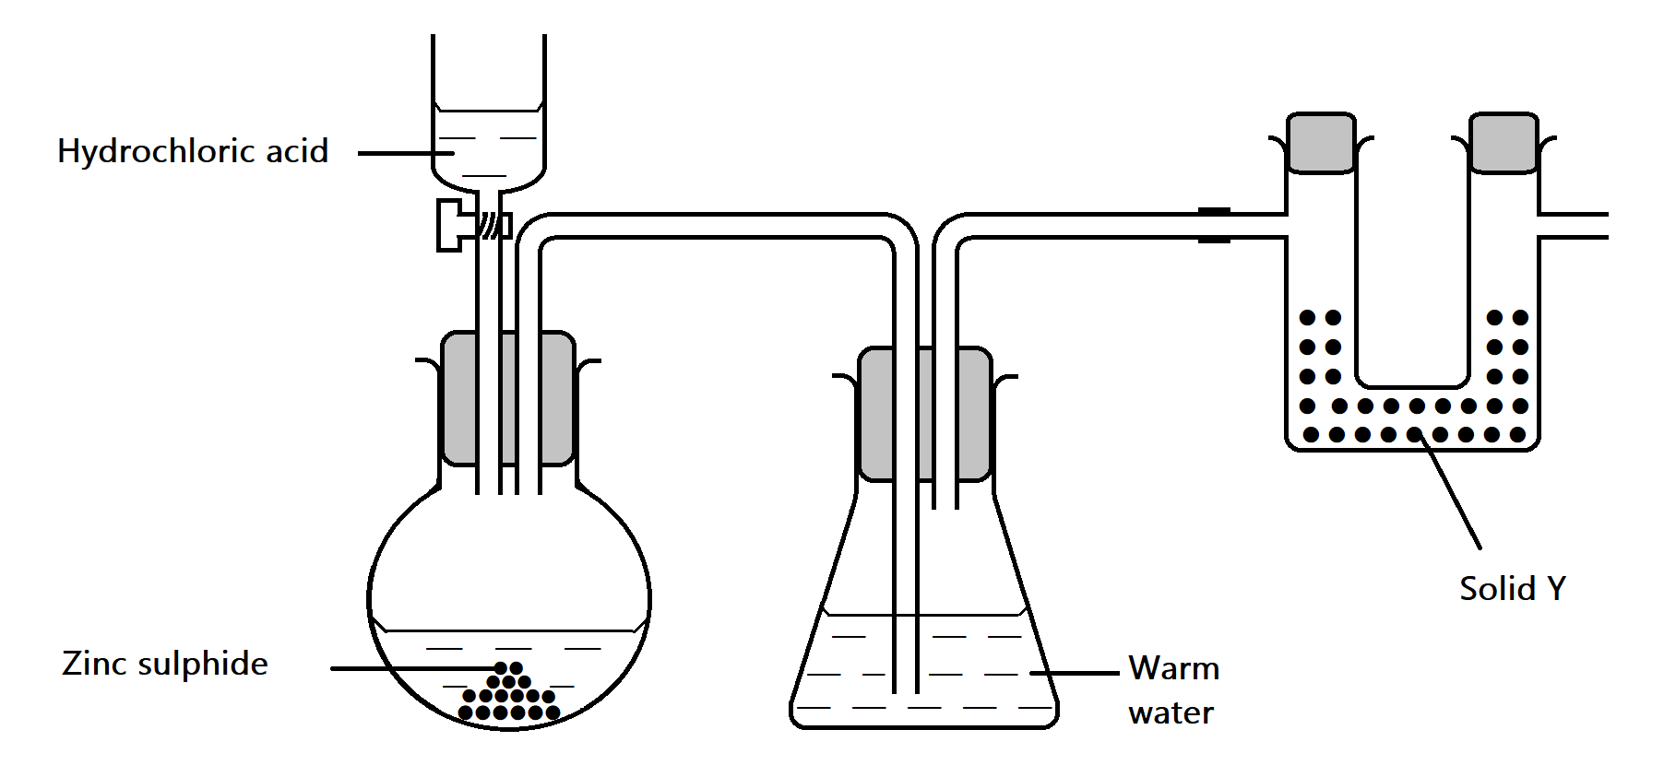
- i) Complete the diagram to show how dry hydrogen sulphide can be collected. (1mk)

ii) Write an equation for the reaction taking place in the round bottomed flask. (1mk)

iii) What precaution is necessary when preparing hydrogen sulphide. (1mk)

iv) Name solid Y. ( 1 mk)

v) State the function of warm water in the conical flask. (1mk)

- State and explain the observations that would be made when hydrogen sulphide gas is bubbled through dilute Nitric (V) acid in boiling tube. (2 mks)

- Using an equation, state the observation made when hydrogen sulphide burns in a limited supply of oxygen. (2 mks)

- The flow chart below are some reactions in organic chemistry. Study the flow chart and answer the questions that follow.
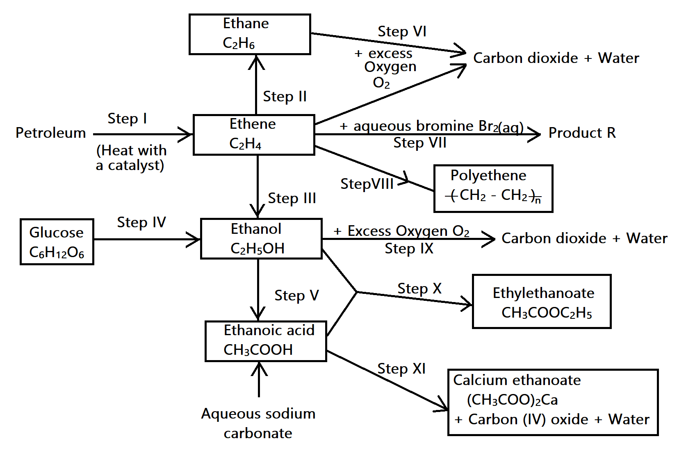

- Name the process in step I (1mk)

- State the conditions and reagents for the reaction in step II. (1mk)
Condition

Reagent

- (i) Name the reaction in step III. (1 mk)

- Suggest a reagent that could be used in step III. ( 1mk)

- Give two conditions that would be necessary for this reaction to occur. (1mk)

(d) Describe step IV under the following headings:
(i) Name of reaction (1 mk)

(ii) Conditions (1 mk)

(iii) Equation (1 mk)

(e)(i) With reference to steps V and X, complete the table below. (1 mks)
Step | Name of reaction
IV
X

(f) Write equations for the reactions in:
i) Step V. (1mk)
ii) Step VII (1mk)
iii) Step X (1mk)

(g) Name the type of reaction in each of the reactions marked:
i) Step VII (½ mk)
ii) Step IX (½ mk)

iii) Step XI (½ mk)

(h) State one use of the product in step VIII. (½ mk)

3. a) The grid below represents part of a periodic table. Study it and answer the questions that follow. The letters do not represent the actual symbols of elements.
S |  |  |  | R | E |  | X
 |  |  |  |  |  |  |  | V
Q | Z |  |  |  |  | M
 |  |  |  |  |  |  | T

- Identify the most reactive non-metal. (1 mk)

- Which of the metals is most reactive? Explain. (2 mks)

- What name is given to the family of elements to which elements X and T belong.
(1mk)

- Give reasons for the following
- Atomic radius of Q is bigger than that of M. (1mk)

- Atomic radius of Q is greater than that of S. (1mk)

- Give an element which does not form compounds under ideal conditions. Explain.
(2mks)

- Give the formula of the compound formed between element R and Z. (1 mk)
b) Study the table below and answer the questions that follow.
Substance | A | B | C | D | E | F
M.P (ºC) | 801 | 119/113 | 139 | -5 | -101 | 1356
B.P (ºC) | 1410 | 445 | 457 | 54 | -36 | 2860
Electrical conductivity (solid) | Poor | Poor | Good | Poor | Poor | Poor
Electrical conductivity (liquid) | Good | Poor | Good | Poor | Poor | Poor

- Identify a substance with;
- Giant metallic structure. (½ mk)

- Simple molecular structure (½ mk)

- Suggest a reason why substance B has two melting points. (1 mk)

- Substance A and C conduct electric current in the liquid state. State how the two substances differ as conductors of electric current. (2 mks)

4. a) The solubility of salt X at various temperatures is as shown in the date given below.
Temperature (ºC) | 0 | 20 | 40 | 60 | 80 | 100
Solubility (g/100g of water) | 10 | 15 | 26 | 40 | 63 | 100

- Using a suitable scale draw a graph of solubility against temperature on the grid provided below. (3 mks)

- A solution containing 20g of salt X in 100g of water was cooled from 50ºC.
- At what temperature will crystals of salt X first form? (1mk)

- Determine the mass of X that crystallizes if the solution is cooled to 12ºC. (2mks)

b) Use the information below on solubility to answer questions that follow.

Salt | Solubility g/100g of water
Salt | 80ºC | 20ºC
KCLO₃ | 55 | 12
Na₂CO₃ | 80 | 36
A mixture containing 30g of potassium chlorate and 30g of sodium carbonate in 100g of water at 80ºC was cooled to 20ºC. Some crystals were formed.
- Which of the two salts crystallized. (1 mk)

- Name the method that can be used to obtain the crystals. (1 mk)

- State the salt that would be unsaturated at 20ºC. (1 mk)

- Magnesium powder was added to the mixture shown in beaker (a) and sodium carbonate added to the mixture in beaker (b). Study the set ups and answer the questions that follow.
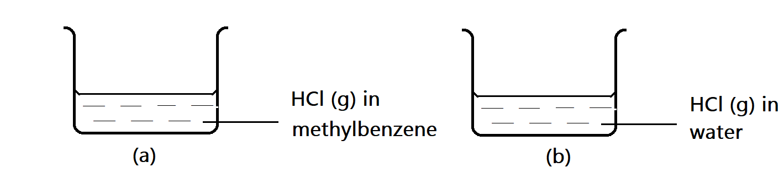
- In which beaker will there be effervescence. (1 mk)

- Explain why there is no reaction in the other beaker. (1 mk)

5. In an experiment to determine the heat of displacement of copper by Iron, 50cm³ of 0.2M Copper (II) sulphate solution was reacted with excess iron filings and following results obtained.
Initial temperature of copper (II) sulphate = 25.0ºC
Final temperature of copper (II) sulphate = 31.0ºC
Mass of iron fillings used =1.0g
(Density of solution 1.0g/cm³, specific heat capacity 4.2Jg⁻¹K⁻¹
- Calculate
- Temperature change (½ mk)
- Mass of solution (½ mk)
- Heat evolved during reaction (2 mks)

- Molar heat of displacement in kilojoules mol⁻¹ (2 mks)

- Write the thermochemical equation for reaction above. (1 mk)

- Explain why excess iron filings were used. (1 mk)

- Draw an energy level diagram for the above reaction. (2 mks)

b) i) What is a fuel? (1 mk)

ii) Give two factors to consider when choosing a fuel for use. (2 mks)
6. In an experiment carbon (IV) oxide was passed over heated charcoal and the gas produced collected as shown in the diagram below.
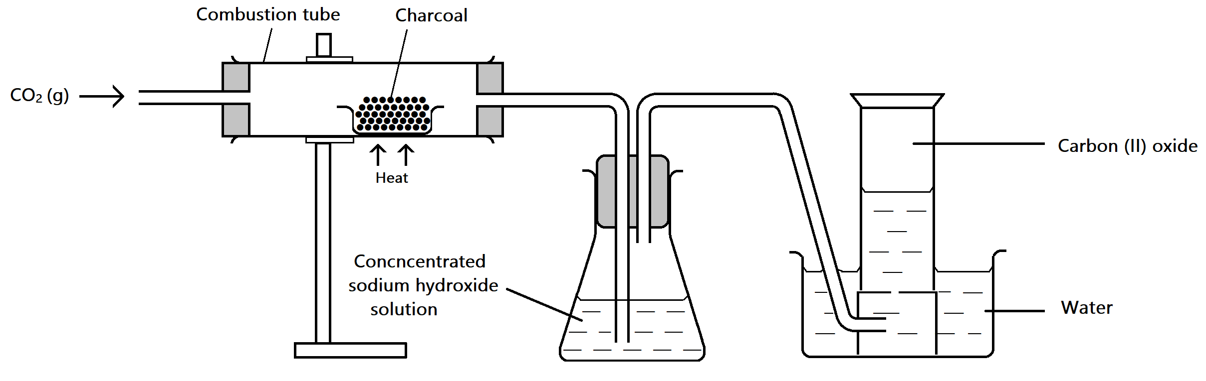

- (i) Write an equation for the reaction that took place in the combustion tube. (1 mk)

- Name another chemical substance that can be used instead of sodium hydroxide.
(1 mk)

- Describe a simple chemical test that can be used to distinguish between carbon (II) oxide and carbon (IV) oxide. (2 mks)

- State one use of carbon (II) oxide. (1 mk)

- In another experiment to synthesize sodium carbonate in the lab students passed carbon (IV) oxide and ammonia gas into brine as shown in the flow diagram below. Use it to answer the questions that follow.

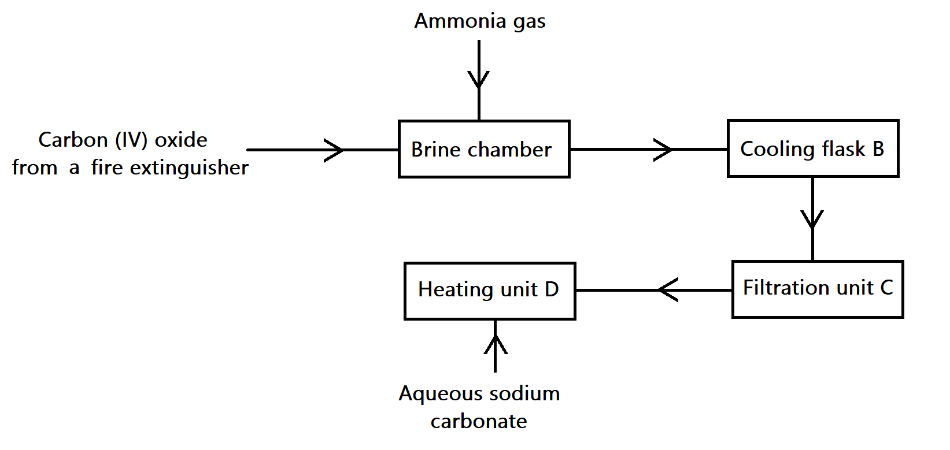

- Why is the mixture obtained in brine chamber cooled in chamber B. (1 mk)

- Give a reason why it is difficult to synthesize potassium carbonate by the same method.

(1mk).

- State two properties of carbon (IV) oxide that enables it to be used in the fire extinguishers. (2mks)

7. The diagram below show an incomplete set-up for apparatus used in preparation and collection of dry ammonia gas.
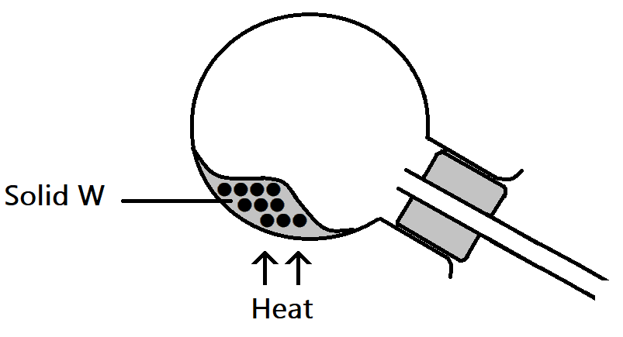

- (i) Complete the diagram to show how a dry sample of ammonia can be obtained. (3 mks)

(ii) Name appropriate substance that can be used as solid X. (1 mk)

(iii) Write equation of reaction that produces ammonia in the above experiment. (1 mk)

- In the space provided below draw a diagram to show how a sample of aqueous ammonia can be prepared. (2 mks)

- Use dot(.) and cross(x) diagram to show bonding in (2 mks)
- Ammonia molecule

- Ammonium ion

- i) State and explain the observations that would be made when excess ammonia gas is bubbled through a solution Iron (II) sulphate. (2 mks)

- Write ionic equation for reaction that occurs in d(i) above. (1 mk)

LAST PRINTED PAGE.

