GEOGRAPHY 312/2
MULTILATERAL EXAMINATION 2026
FORM FOUR MARCH/APRIL 2026
PAPER 312/2
TIME: 2HR: 45 MIN
MARKING SCHEME

INSTRUCTIONS TO CANDIDATES.
- THIS PAPER HAS TWO SECTION A AND B
- ANSWER ALL THE QUESTIONS IN SECTION A .
- IN SECTION B, ANSWER QUESTIONS 6 AND ANY OTHER TWO.
SECTION A (25MARKS SECTION A
ANSWER ALL QUESTIOS FROM THIS SECTION
1. (a). State three areas of study in practical geography (3Marks)
- Cartography/ Map work
- Fieldwork
- Photograph work
- Statistical methods
( 3 x 1= 3 Marks)
(b). Outline two relationships between geography and biology (2Marks)
- Geography uses biology to explain factors that influence distribution of plant and animals species on earth in topics like wildlife vegetation and forestry
- Biology uses geography to explain reasons why some plants and animals species exist in certain areas (2 X 1 = 2Marks)
2.(a)Identify three factors that influence the occurrence of minerals (3marks)
- Magmatic activity
- Metamorphism
- Weathering and erosion
- Sedimentation ( 3 x 1= 3 Marks)
(b). Give locations where the following minerals are found
(i). Diatomite- Kariandusi (1Marks)
(ii). Salt: Magadi in Kjiando/Coastal region (1 Marks)
3. (a).Give two reasons why it is necessary to conserve wildlife in Kenya 2marks
- To protect the endangered animals and plants species
- To promote tourism in the country
- To generate foreign exchange and earn revenue to the country
- To keep animals and plants for prosperity and future generation
- To restrain the availability of raw materials from the plant for the manufacture of drugs.
(3 x 1 = 3 Marks)
(b). State thee effects of human encroachment into the wildlife habitat (3marks)
- Habitat loss and fragmentation
- Loss of biodiversity
- Disruptions of food chain
- Human wildlife conflict (3 x 1 = 3 Marks)
4.(a). Name three agricultural food processing industries in Kenya (3marks)
Tea processing Fruit canning/processing
Coffee processing Brewing Meat canning
Milk Processing Rice milling Oil pressing
Sugar Refining Bakery Vegetable canning
(3 x 1 = 3 Marks)
- (b). Give two reasons why paper industries are located near rivers. (2marks) Water is needed for cleaning.
- Industries use water for cooling machines.
- Water is used for grading some products.
- Water is used in industries
- as a medium through which wastes are disposed.
- It is located near rivers which provide hydroelectric power used in the industry.
- Water is used as a raw material in the industry.
- Water is used for debarking logs. (3 x 1= 3 Marks)
5. (a). Name two deep sea fishing methods (2marks)
- Seining
- Trawling
- Drifting
- Long lining
- Whaling/ Hapooning ( 3 x 1 = 3Marks)
(b). State three physical conditions that favour fishing in North Atlantic fishing ground (3marks)
- High latitudes/ cool waters encourage the flourishing of fish.
- Broad shallow continental shelf that favours the growth of planktons.
- Ruggedness of the land of the immediate surrounding hinders agriculture favouring fishing as an alternative economic activity.
- Presence of warm Atlantic drift ocean current makes the waters free from ice supporting fishing.
- Numerous fiords along the coast provide shelters for the spawning of fish and landing fishing boats.
( 3 x 1 = 3Marks)

SECTION B
INSTRUCTIONS: Answer Question Six And Any Other Two Questioins From This Section
6. The table below shows contribution of various energy sources in Kenya in thousand dollars.

Type of power | 2018 | 2019 | 2020 | 2021
Hydropower | 90,000 | 110,000 | 119,000 | 150,000
Geothermal | 110,000 | 121,000 | 151,000 | 190,000
Thermal | 28,000 | 43,000 | 52,000 | 38,000
Total | 228,000 | 274,000 | 322,000 | 378,000

- 274,000 ÷ 50,000 = 5.48cm radius 2.8cm
- 322,000÷ 50,000 = 6.4cm radius 3.2cm
- 378,000 ÷ 50,000 = 7.56 =7.6cm radius 3.8
Using a scale of 1cm represent 50,000 dollars, draw proportional circles to represent the total revenue earned from Various energy sources during the period of 2019 to 2021. Use diameter method. (6marks)

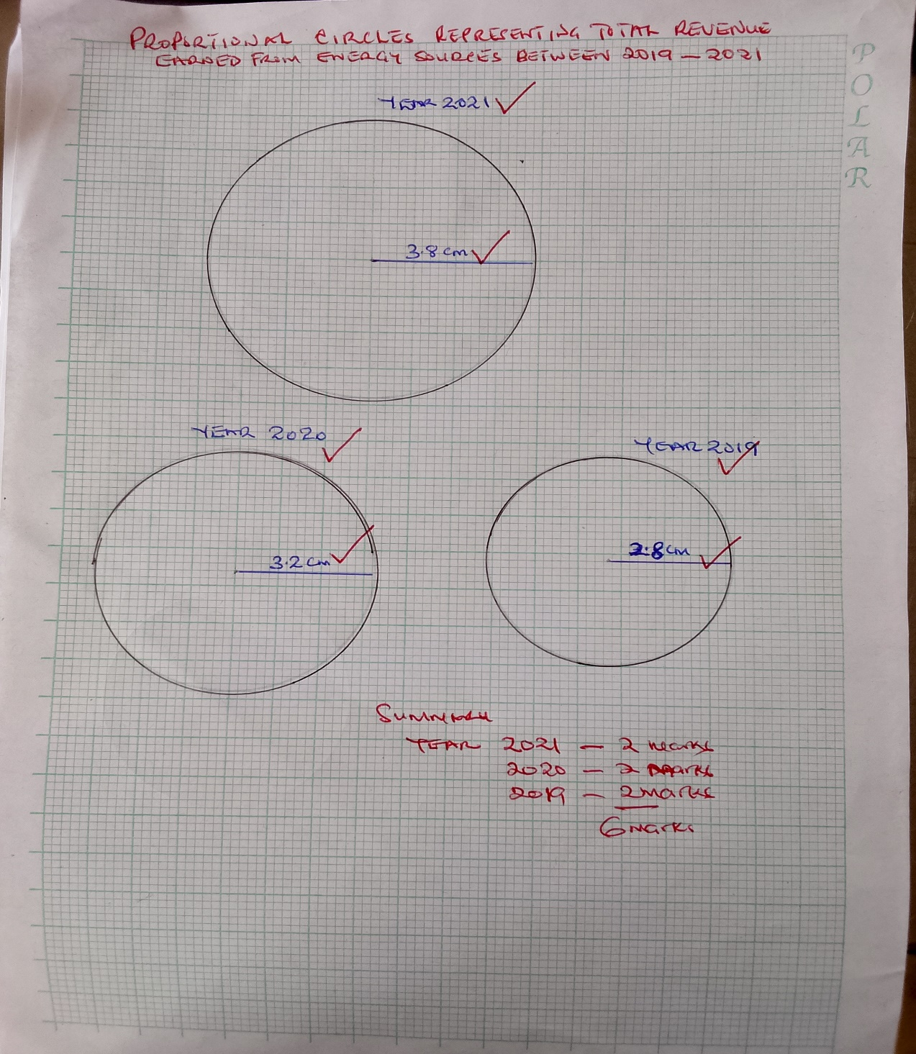

(ii). Give three advantages of using proportional circles in representing data
- Give clear visual impression.
- Easy to construct.
- Easy to interpret.
- Allow comparison ( 3 x 1 = 3Marks)
(a). i).Outline four disadvantages of using draught animals as a means of transport in Kenya.
- Animals are prone to diseases and fatigue.
- Their use is restricted only to rural areas.
- They need regular rest as they tire easily.
- They can die as a result of too much work.
- They can only do limited work. ( 4 x 1 = 4Marks)
(ii)State three factors that have hindered the development of solar energy in Kenya
- Solar energy has low energy output.
- The short life span of storage batteries.
- Competition from alternative sources.
- High cost of purchasing/ installation of solar panels/ low purchasing power of people.
- Inadequate technology. (3 x 1 = 3Marks)
(3 x 1 = 3Marks)
(ii). State three ways in which Kenya can reduce the use of petroleum as a source of energy(3Marks)
- Encourage people to use bicycles/ boda bodas over short distance
- Developing alternative sources of energy
- Pooling transport
- Encourage people to use public transport
- Importing vehicles that consume less fuel
- Improving traffic flow to reduce usage of petrol
- Improving roads to avoid delay that increases consumption of Petrol and diesel.
- Proper maintenance of vehicles to avoid high consumption of petrol/ diesel.
(4 x 1 = 4Marks)
d. Explain three benefits that would result from rural electrification in Kenya (8 Marks)
- It would encourage setting up of industries in the rural areas thus stimulating decentralization of industries.
- It would reduce the cutting down of trees and electricity would be available for domestic use.
- It would attract/improve social amenities in rural areas reducing the need for people to move to urban areas.
- Most people would invest in the rural areas, which would lead to higher standards of living.
- It would encourage development of horticultural farming / to have ideal storage of perishable of products.
(6 x 2 = 6Marks)
7. (a) (i)Identify two processes used to reclaim swamps in kenya
- Digging ditches, directing the swamps water down the slope
- Laying pipes in the swamps to direct water out of the area
- Regulating and controlling the water that feeds the swamp by building dykes Pumping out the water.
- Planting trees/ eucalyptus/ vegetation/ bananas.
( 2x 1 = 2 marks)
(ii). List three irrigation methods used in Kenya (3marks)
- Overhead irrigation
- Canal or farrow irrigation
- Drip irrigation
- Flood irrigation
- Lifting water with containers from a river or well
(3 x 1 = 3 Marks)
(b). Explain how the following geographical factors favour irrigation in Mwea
Tembere.
(i).Topography : Gently sloping land which make it possible for water to flow by gravity in and out of the irrigated fields which eliminates the high cost of pumping/mechanization
(2 Marks)
(ii).Climate: High temperatures make the area suitable for rice cultivation/ unreliable rainfall in the area made irrigation necessary
Availability of irrigation water that provides constat supply of water for irrigation from rivers Thiba and Nyamindi and Murubara (2 Marks)
(iii).Soils: Presence of deep, black cotton soils or clay soils which is suitable for cultivation of rice because it retains water (2Marks)
( c). Explain how the following problems affect irrigation farming in Kenya
(i). Presecnce of weeds in the farm: weeds keep germinating in the rice field competing for niutrients with the crop under cultivation thus lowering the yields (2Marks)
(ii). Low volume of water during the dry season: Low volume of water during the dry season reduces the amount of water required for irrigation. (2Marks)
(iii): Expensive Farm inputs: Expensive farm inputs lowers the profit margin as it discourages the farmers lowering their income. (2Marks)
(d). Explain four differences between land reclamation in Kenya and the Netherlands
(8Marks)
- In Kenya the area that is reclaimed is relatively small while the area reclaimed in the Netherlands is large
- In Kenya land is mainly reclaimed from swamps and marginal areas while in Netherlands reclamation is from the sea
- In Kenya irrigation is used as a means of reclaiming dry areas while in the Netherlands irrigation is used to lower the salinity of the soil in the Netherlands lands
- In Kenya the methods of land reclamation are simple/ digging canal/ditches to drain water from the land while in Netherlands the method used are highly advanced like reclaiming land from the sea/creation of polders
- In Kenya dykes are used to control rivers floods while in Netherlands dykes protect the reclaimed land from invasion by the sea.
(4 x 2 = 8 Marks)

8.a(i) What is dairy farming? (2mks)
- This is the practice of keeping cattle for milk/the rearing of cattle for purpose of milk production. ( 2Marks)
(ii)Name two exotic dairy breeds of cattle reared in Kenya. (2mks)
- Fresian/Holstein
- Ayshire
- Guernsey
- Jersey
- Alderney
- Swiss brown ( 2 x 1 = 2Marks)
b(i). State three human factors that favour dairy farming in Rift Valley(3mks)
- Availability of labour from the high population.
- Presence of milk processing factories in the region.
- Well developed transport network in the region.
- Presence of milk cooperatives in the region.
- Availability of extension/ veterinary services for the farmers.
(3 x 1 = 3Marks)

(ii). Explain four ways in which the Government of Kenya assists Dairy farmers. (4mks)
- Appointing supervisory boards to run the cooperatives.
- Extending credit facilities to farmers through cooperatives.
- Holding agricultural shows to educate farmers on better dairy management.
- Setting up demonstration farms which breed high quality bulls for farmers.
- Establishing well maintained roads for easy delivery of milk.
- Carrying out extensive research on possible solutions to animal diseases.
(4 x 1 = 4 Marks)

c). Explain four problems facing dairy cattle farming in Kenya. (8mks)
- Stiff competition from imported milk and milk products makes the industry unsuitable.
- Poor management of dairy co-operatives result to misappropriation for funds hence delayed payments to farmers kill their morale
- Inadequate capital to buy the necessary farm input hence minimizing mechanization of the farming/makes it difficult to plan ahead.
- Prolonged drought /unreliable rainfall leads to shortage of pasture leading to poor quantity breeds.
- Outbreak of diseases weaken and even kill the cattle which is a loss to farmers.
- Expensive farm inputs leads to reduced quality hence reducing profit margin.
- Inadequate feeds/water during the dry seasons leads to undernourishment of cattle and thus low yields.
- Stiff competition from alternative land uses e.g. horticulture, tea and coffee lowers the quality of milk production.
- Low prices of dairy products mke farmers unable to plan ahead.
- Poor storage facilities/cooling centres cause the milk to go bad leading to heavy losses to farmers.
- Exploitation from middlemen leads to low prices/low profits discouraging farmers
- Underdeveloped feeder roads in the production areas makes the milk perish before reaching the markets creating loss to farmers.
( 4 x 2 = 8Marks)

(dExplain three reasons why dairy farming is highly developed in Denmark than Kenya. (6mks)
- Denmark’s dairy farming is highly mechanized since capital is available that leads to high production while in Kenya, there is limited mechanization due to inadequate capital.
- Dairy farming in Denmark is highly specialized while in Kenya most farmers practice mixed farming.
- Dairy farming in Denmark is leased affected by climatic variations .
- In Denmark artificial insemination (Al) or extension services are widely used unlike in Kenya artificial insemination or extension service are limited to few farms.
- Research is widely /extensive while research in Kenya is limited.
- In Denmark co-operative movement is highly developed while in Kenya its less developed
( 4 x 2 = 8 Marks)

9. (a). (i).Differentiate between forest and forestry (2marks)
- Forest is a continuous undergrowth of trees and undergrowth covering a large track of land while forestry is the act of developing and managing forests
(2 Marks)
(ii). Explain four factors influencing distribution of natural forests in Kenya
- The area which receive high rainfall /100-2200mm per year/wet conditions have continuous growth of trees/dense forest/areas that receive low rainfall have scattered trees
- Cool/warm conditions/hot/high/moderate/low temperatures encourages growth of variety of trees/ Very cold/very hot conditions/very low/very high temperatures discourages growth of trees
- Deep, well drained soils support growth of trees since they allow the roots to penetrate deep into the ground/sandy/thin soils discourages growth of trees/mudflats soils along the shallow coastline leads to growth of mangrove forests.
- Areas which are gazette as forest reserves are prohibited from human settlement/cultivation hence forests grow without interference.
- Some steep slopes are covered by forests since there are limited human activities.
- Population pressure has led to clearing of some forested areas for settlement/ cultivation.
- High demand for woods fuel/Timber has led to cutting down of trees
- Forest fires reduce areas under forests
Some wild animals eg. Elephants destroys forests
( 4 x 2 = 8 Marks)
( b ). (i).Name three types of hardwood trees found in Kenya.
- Mvule Mahogany Wattle
- Elgon teak Eucalyptus Umbrella tree/Maesopsis eminii
- Meru oak Coconut pum Prunus Africanus
- Camphor Jacaranda Bombax tree
- Elgon Olive Sapele Rose wood
- Mangrove Nandi flame Croton
- Acacia Bamboo tree Iron wood
- Beech Ebony/Mpingu
- MarkhamiaLutea/ Nile tulip Sundal wood
(3 x 1 = 3 Marks)
(ii). Give four characteristics of coniferous forests
- Trees have straight trunk
- The trees are cone shaped
- The tres have thick barks
- Most of the trees are evergreen/ a few are deciduous
- The trees have narrow needle like leaves
- The species occur in pure stand
- The trees are soft wood
- There is little undergrowth
- The trees have shallow roots
- Trees take long to mature/ 50-70 years
- Trees produce cones
- Trees are tall
- Trees have waxy barks /leaves
- Trees produce resins
- Trees trunk /branches are flexible ( 4 x 1 =4 Marks)
(c). (i) Explain four ways in which clearing of forests has affected natural environment of Kenya (4Marks)
- It has led to reduced volume of water in the rivers/caused drying up of rivers.
- It has led to destruction of natural habitat for wildlife.
- It has led to changes in the rainfall pattern/ desertification.
- It has interfered with the beauty of the environment.
- It has disrupted the ecosystem.
- It has accelerated soil erosion.
(4 x 1 = 4 Marks)
(ii)Give the difference in exploitation of softwood in Kenya and Canada under the following sub headings
Period of harvesting (2marks)
- In Kenya harvesting period is through out the year while in Canada harvesting is during winter and early spring (2 marks)

Transportation (2Marks)
- In Kenya transport is by road while in Canada mainly water transport is used (2Marks)

10. (a)(i). what is agriculture ? (2marks)
It is the practice of culticating of crops and rearing /keeping of livestock for subsistence or commercial purpose. (2Marks)
(ii). Identify three features of intensive crop farming (3 marks)
- Crops grown are for sale
- The land/soils are utilized intensively
- Irrigation is practiced where rainfall is insufficient
- The land is generally small in size
- There is heavy application of fertilizers
- Manual labour is applied to take care of crops
- In some cases there is specialization
( 3 x 1 = 3Marks)
(iii). State three problems facing plantation farming (3 marks)
- Monoculture lead to soil deterioration.
- Heavy tropical rainfall washes away soils leading leaching/erosion
- Climatic hazards such as hailstones draught, local winds damages crop lowering yields
- Hot and humid conditions cause pests and diseases reducing productivity.
- Mismanagement of some plantation causes heavy loses.
( 3 x 1 = 3Marks)
b.(i)Name two cocoa growing area in Ghana (2 Marks)
- Akwapim
- Sunyani
- Kumasi
- Koforidua
- Mampong escapments ( 2 x 1 = 2Marks)
(ii). Describe commercial growing of Cocoa from harvesting to processing (6marks)
- When cocoa pod are ripe they turn yellow and they are cut off the branches and stems using a long knife
- The pods are put in a heap in the farm
- A knife is used to split up the pod and the beans removed by hand
- The beans are placed on the mats and covered with banana leaves for fermentation
- After fermentation the beans are washed cleaned and taken back to the farmer’s home where they are spread on raised platforms to dry ( They are constantly turned as they dry.)
- The dry beans are put in bags and taken to collection centres for inspection.
- The cocoa beans are packed and transported to the port for export.
( 6 x 1 = 6Marks)
c. (i). Name three cocoa growing countries in Africa
- Ghana
- Cote de ivore
- Nigeria
- Cameroon ( 3 x 1 = 3Marks)
(ii). Explain three factors favouring Cocoa growing in Ghana
- Moderate to high rainfall from 1270 mm-1500mm PA well distributed through out the year
- High temperatures/24°c-30°c
- High relative humidity 75%-80%
- Deep well drained soils
- Low altitude 700 above sea level
- Gently sloping/ undulating landscape
- Cheap labour during planting and harvesting
( 3 x 1 = 3Marks)
(iii). what is the significance of cocoa in Ghana’s economy
- Account to 60% of Ghanas earnings
- Revenue has been ploughed back to improve infrastructure
- Offers employment
- Improves stardands of living for the farmers
( 3 x 1 = 3Marks)

