NAME ……………………………………….… ADM NO……….… DATE …….………
SCHOOL…………………………………………...………SIGNATURE…………...…….
121
MATHEMATICS
FORM 4 PAPER 2
MARCH/APRIL 2026
TIME: 2 ½ HOURS
END OF TERM ONE EXAMINATION
Kenya Certificate of Secondary Education 2026

INSTRUCTIONS TO CANDIDATES
- Write your name and admission number in the spaces provided at the top of this page.
- This paper consists of two sections: Section I and Section II.
- Answer all questions in section I and any five questions in Section II.
- Show all the steps in your calculations, giving your answers at each stage in the spaces below each question.
- Marks may be given for correct working even if the answer is wrong.
- KNEC Mathematical tables may be used.

For Examiner’s Use Only

1 | 2 | 3 | 4 | 5 | 6 | 7 | 8 | 9 | 10 | 11 | 12 | 13 | 14 | 15 | 16 | Total

17 | 18 | 19 | 20 | 21 | 22 | 23 | 24
Grand
Total

SECTION A
Answer all questions in this section

- Use logarithms tables to evaluate. (4mks)

- Simply and leave answer in surd form. (3 marks)
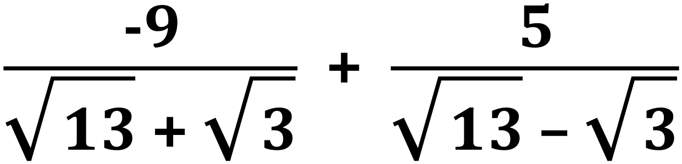

- Water flows from a circular pipe of diameter 3.5cm into a rectangular tank 66cm long, 35cm wide and 45cm high. If it takes 18 minutes to fill the tank completely, determine the rate of flow of the water in the pipe in cm/s? (3 marks)

- In the figure below O is the centre of the circle ABCD and AOD is a straight line. If AB=BC and angle DAC=80 calculate <BAC

B C

A D

- The figure below is a graph of $y={2x}^{2}$ for $-1.5≤x≤2.5$. (3marks)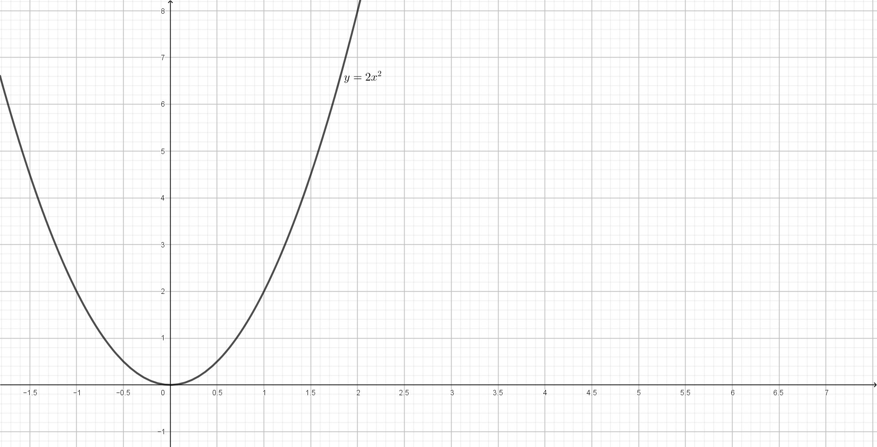
Use the graph to find the rate of change at:
- $x=1.5$

- $x=-0.8$

- Working together two taps A and B can fill a tank in 2 hours. By itself tap A can fill the tank in 6 hrs. Tap A and B are opened at the same time and after running for 1 hours, an outlet tap which can drain the full tank by itself in 12 hours is opened and Tap A is closed. Find the total time taken to fill the tank. (4 marks)

- A Kenyan bank buys and sells foreign currencies as shown below

Buying Selling
Ksh Ksh
1 Hong kong dollar 9.74 9.77
1 South African rand 12.03 12.11
A tourist arrived in Kenya with 105,000 Hong kong dollars and changed the whole amount to Ksh while in Kenya she spent Ksh 403,897 and changed the balance to South African rand before leaving for South Africa. Calculate the amount in South African rand she received (3mks)

- a) Expand and simplify the binomial expression $({2+x)}^{5}$ upto the term in $x^{3}$. (2 marks)

b) Use your expression to estimate the value of $({1.97)}^{5}$ (2 marks)

- Make y the subject of the formula in: (3marks))
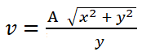

- Using Logarithms evaluate
Log(x-1) + Log(x+1) = 1+ Log4 (3 marks)

- Below represents a cuboid PQRSTUVW in which UV = 4.5cm, VW = 8cm and WR = 6cm

Calculate the size of the angle between the lines UR and UW (3 marks)

- Find the length of an arc of a circle which subtends an angle of 0⋅8 radians at the centre of the circle. The radius of the circle is 15 cm. (3 marks)
- The Length of a triangle is 8.3cm and its windth is 5.4cm. Calculate the percentage error in the area (3mks)

- The diagram below shows a circle center O. BF is a tangent to the circle at B. Angle ${DAC=20}^{0}$ and angle $FBD={50}^{0}$
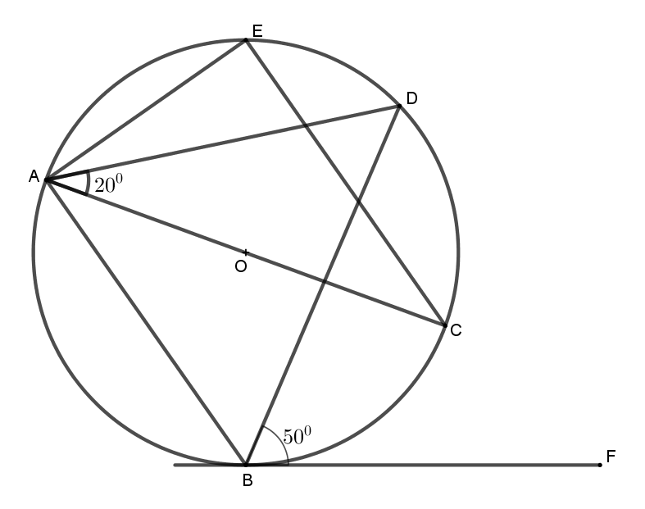

Giving reasons find;
- Angle AEC (2 marks)

- The position vectors of points P and Q are $p = -2i - j + k$ and $q =4i -5j – 2k$ and respectively. Find the magnitude of OM if M is a point that divides PQ in the ratio 1:2 correct to 4 significant figures. (3marks)

- A triangular plot PQR is such that PQ=72m, QR=80m and PR=84m. If the area of the plot is in square metres is 2648.2. Find the acute angle between PQ and PR. (3marks
SECTION B
Answer five question only on this section
- The table below shows the distribution of marks scored by 60 students in a test.
Marks | 11-20 | 21-30 | 31-40 | 41-50 | 51-60 | 61-70 | 71-80 | 81-90
Frequency | 2 | 5 | 6 | 10 | 14 | 11 | 9 | 3
- On the grid provided draw a cumulative frequency curve of the data. (3 marks)
(Take 1cm to represent 5 students on the vertical scale and 1 cm to represent 10 marks on the horizontal scale).
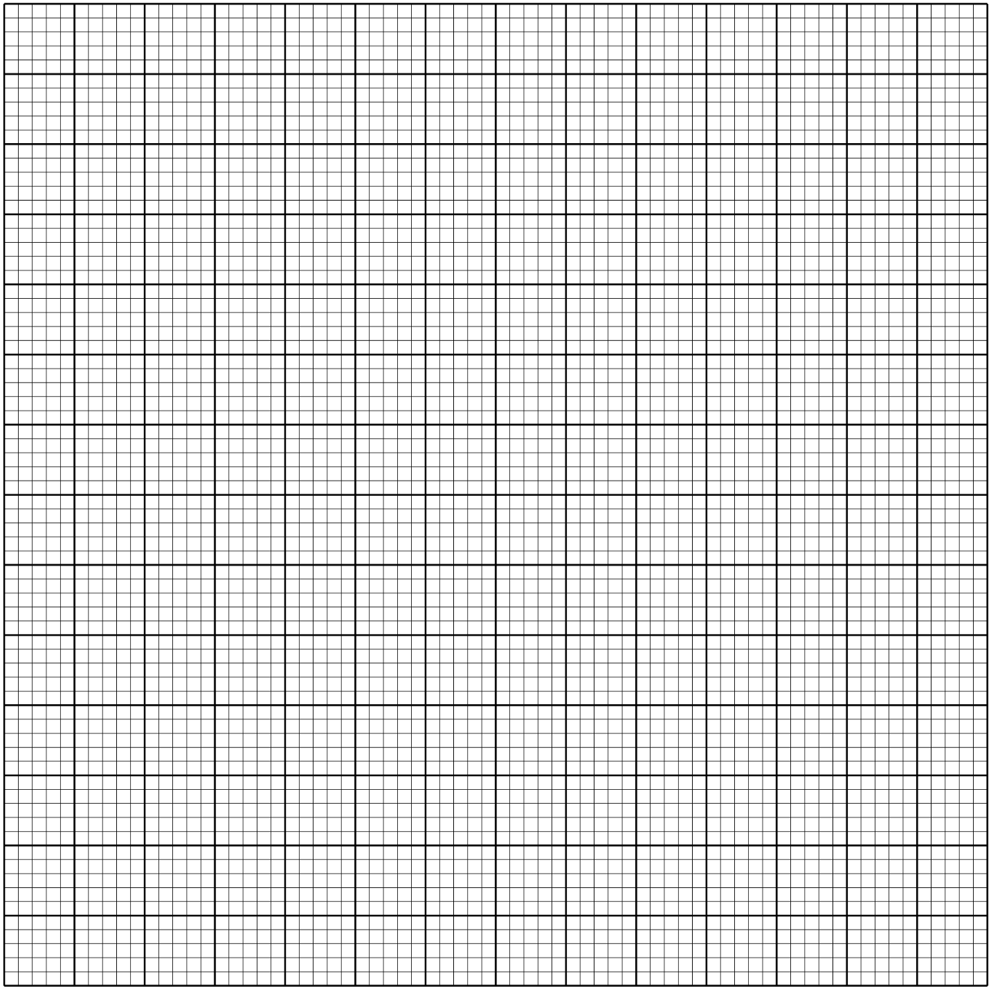

- From the curve in (a) above
- Estimate the median mark (1 mark)

- Determine the quartile deviation. (2 marks)

- Determine the 10th and 90th percentile range. (2 marks)

- It is given that students who score over 45 marks pass the test. Use your graph in (a) above to estimate the percentage of students that pass. (2 marks)

- The following table shows the rate at which income tax was charged during a certain year.
Monthly taxable income in Ksh. | Tax rate %
0 - 9860 | 10
9861 - 19720 | 15
19721 - 29580 | 20
29581 - 39440 | 25
39441 - 49300 | 30
49301 - 59160 | 35
over 59160 | 40

A civil servant earns a basic salary of Ksh.35750 and a monthly house allowance of sh.12500 and non taxable allowance of ksh 10000. The civil servant is entitled to a personal relief of sh.1062 per month. Calculate:
a) Taxable income (2 marks)

b) Calculate his net monthly tax (5 marks)

c) Apart from the salary the following deduction are also made from his monthly income.
WCPS at 2% of the basic salary
Loan repayment Ksh.1325
NHIF sh.480
Calculate his net monthly earning. (3 marks)

- a) The first and the last terms of an arithmetic progression are 4 and 134 respectively. Given that the sum of the terms is 1,863
Find, (i) The number of terms in the sequence (2 marks)

(ii) The common difference of the sequence (2 marks)

(b) The third, fifth and eighth terms of another Arithmetic Progression form the first three consecutive terms of a Geometric Progression. If the common difference of the Arithmetic Progression is 3,
Find: (i) Ther first term of the Geometric Progression. (4 marks)

(ii) The sum of the first twelve terms of the Geometric Progression. (2 marks

- ABC is a triangle with vertices A (-7, 2) B (-2, 1) and C (2, 8). A¹B¹C¹ is the image under transformation.$\left[\begin{matrix}-1 & 0 \\ 0 & -1\end{matrix}\right]$
a. (i) Find the co-ordinates of A¹B¹C₁ (2marks)

(ii) On the grid provided draw ABC and A¹B¹C¹ (2marks)
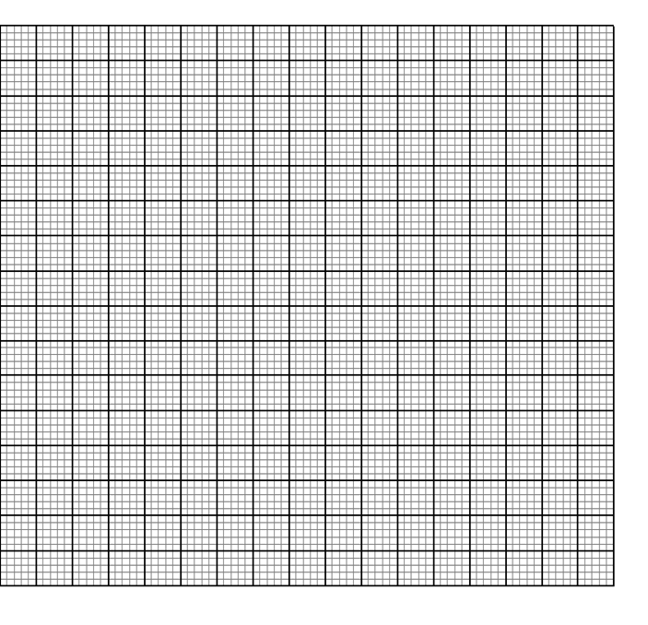
b. (i) Find the co-ordinates of A¹¹B¹¹C¹¹ the image of a triangle A¹B¹C¹ under
transformation matrix. $\left[\begin{matrix}0 & -1 \\ -1 & 0\end{matrix}\right]$ (2marks)

(ii) On the same grid draw A¹¹B¹¹C¹¹ (1marks)
c. (i) Find the single matrix that maps A¹¹B¹¹C¹¹ onto A¹B¹C¹ (2marks)

(ii) Describe the transformation represented by the matrix in c(i) above (1mark)

- a) Complete the table below for $y = -2 sin x$ and $y = 3 cos x.$ (2 marks)
x | 0° | 30° | 60° | 90° | 120° | 150° | 180° | 210° | 240° | 270° | 300° | 330° | 360°
-2 Sin x | 0.00 |  | -1.73 |  |  | -1.00 | 0.00 |  |  | 2.00 | 1.73
3 Cos x | 3.00 |  | 1.50 |  |  | -2.60 | -3.00 |  |  | 0.00 | 1.50

b Draw the graph $y = -2 Sin x$ and $y = 3 cos x$ using 1 cm to represent 30° horizontal axis and 2 cm to represent 1 unit on the vertical axis. (5marks)
c) Use the graph to solve:
i) 3 Cos x + 2sin x = 0 (1 mark)

ii) 1 - 2sin x = 2 (2 marks)

- A number is selected at random from numbers 10,11,12, and 13. A second number is selected at random from the numbers 3,4,5 and 6. Afterwards a product of the numbers is obtained by multiplying the first number selected by the second number
i) Complete the table below (2marks)

x | 10 | 11 | 12 | 13
3
4
5
6

ii) Determine the probability that the product obtained is an odd number (2mks)

iii) Determine the probability of that the product obtained is a number less or equal to 40 (1mk)

b) A bag contains 2 red balls and 7 green balls. The balls are identical except for the colours. Two balls are pickedat random without replacement.
i) Draw a tree diagram to show all the possible outcomes (1mk)

ii) Determine the probability that the balls picked are of the same colours (2mks)

iii) Determine the probability that the balls picked are of different colours. (2mks)

- In the triangle OAB, $\vec{OB}$ = $\underbrace{b}$ , $\underbrace{OA}$ = $\underbrace{a}$. Point N is on OB such that the ratio ON:NB=1:2 and the point M divides AB in the ratio 1: 3 line OM and AN intersect at point X.
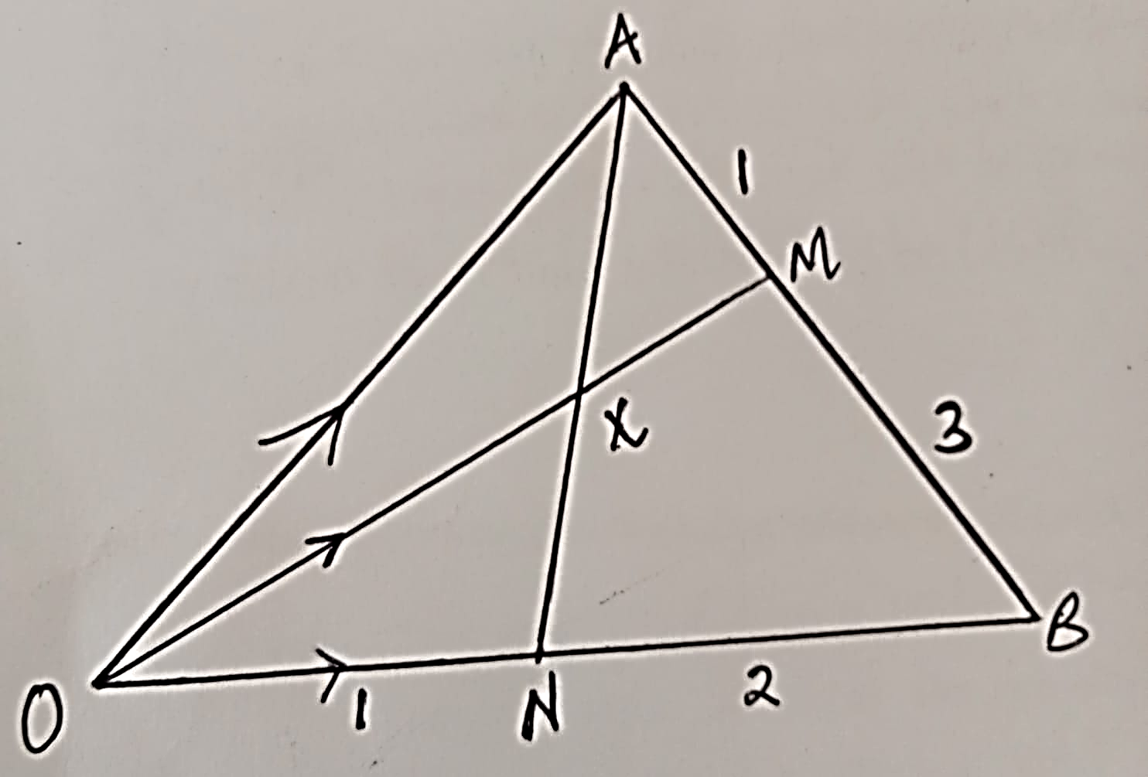
(a) Express in terms of vectors $\underbrace{a}$ and $\underbrace{b}$ ,
(i) $\vec{ON}$ (1mark)

(ii) $\vec{OM}$ (2marks)

b) Further given that $\vec{OX}$ =h $\vec{OM}$ and OX =kAX, where k &h are scalars,
(i) Express $\vec{OX }$ in two different ways. (2marks)

(ii) Find the value of k and h. (4marks)

(c) Find the ratio AN: NX (1mark)
24. Three quantities P, Q and R and such that P varies directly as the square of Q and inversely as the square root of R.
a) Write an expression of P in terms of Q and R (1 mark)

b) Given that when P = 40, Q = 10 and R = 16. Find the value of P when Q = 7 and R = 64 (4 marks)

c) If Q is increased by 10% and R is decreased by 19%, find the percentage change in P.
(5 marks)

