NAME: ………………………………………………..…CLASS:….…ADM NO:…………
SIGNATURE:…………………………………
DATE…………………………………………
232
Physics
FORM 3
TERM 1 2026

Instructions to candidates

- This paper consists of two sections A and B.
- Answer all the questions in the two sections in the spaces provided after each question
- All working must be clearly shown.
- Electronic calculators and Mathematical tables may be used.
- All numerical answers should be expressed in the decimal notations.

For Examiner use only
SECTION | CANDIDATE’S SCORE
A (40MKS)
B(60MKS)
TOTAL

SECTION A 40 MARKS
- (a) Mechanics is one of the branches of physics. State what it deals with ( 1mk)

(b) State one way in which physics contribute to the study of home science (1mk)

- (a) In a physics experiment a student filled burette with water up to a level of 15ml. The student ran out 3 drops of water each of volume 2cm3 from the burette into a beaker. Determine the final reading of the burette. (2mks)

(b) The diameter of a wire was measured as 2.43mm. Name the instrument that was used to measure the diameter (1mk)

(c)The following data was obtained from an experiment to determine the size of palm oil molecule.
  - Volume of 100 drops of palm oil =15.0mm³.
  - Area of a patch from one drop of oil =8.0 x 10⁴ mm².
Determine the size of a palm oil molecule (3mks)

(a) Explain why water in a glass tube forms a concave meniscus (2mks)

(b) A solid weighs 16.5N on the surface of the moon. The force of gravity on the moon is 1.7 N/kg. Determine the mass of the solid. (3mks)

- (a) State the meaning of the term matter (1mk)

(b) It is observed that when a liquid is heated it's volume increases. Explain this observation using the kinetic theory of matter (3mks)

- (a) The figure below shows a round bottomed flask fitted with a long capillary tube containing a drop of coloured water.
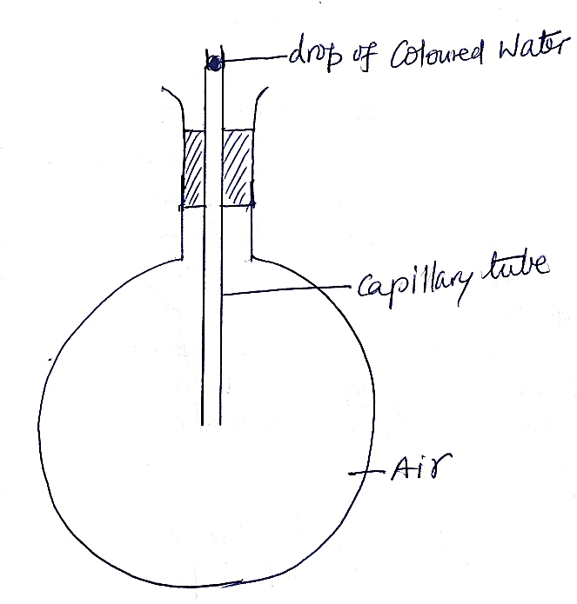
The flask is immersed in ice for some time.
State the observation made (2mks)

(b) A boarding school has two identical tanks A and B filled with water. All the surfaces of tank A are painted silvery shinny while the surfaces of tank B are painted black. It is observed that, for bathing in the morning, most of the students prefer fetching water from one particular tank.
(i) Identify the tank preferred by the students in the morning (1mk)

(ii) Explain why students prefer to use water in the tank identified in (I) above (2mks)

- (a) State two differences between. Electrostatic induction and charging by contact. (2mks)

INDUCTION | CONTACT

(b) When a negatively charged rod is brought near a cap of a leaf electroscope the leaf rises . Explain this observation (2mks)

- Two springs of negligible weights and spring constants k1=50N/M and k2 =100N/M are connected end to end and suspended from a fixed point. Determine the total extension when a mass of 2.0 is hung from the lower end (4mks)
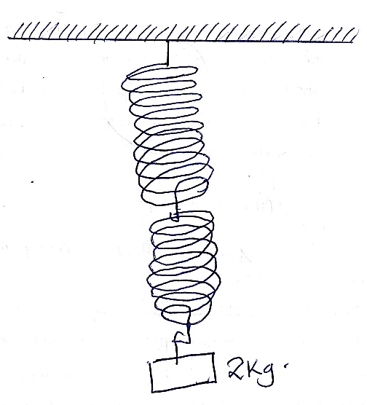

- (a)Why is repulsion the sure test for a magnet? 2mks.
(b) The diagram below shows two magnets and a soft iron ring between them
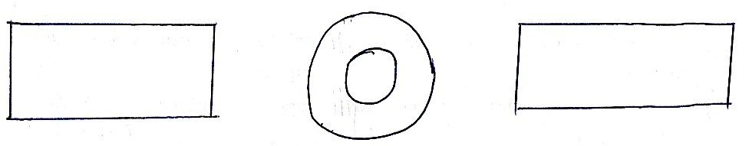
Draw the magnetic field pattern in the set up above (2mks)

- The uniform rod of length one meter shown in the figure below is in equilibrium
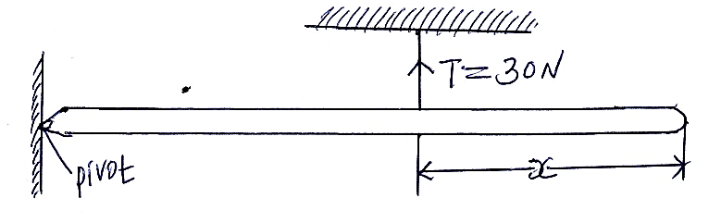
Find the value of x if the weight of the rod is 40N (4mks)

- Water flows through a narrow pipe of radius 6cm connected to another pipe of radius 9mm. If the speed of water in the narrow pipe is 3m/s determine the speed of water in the wider section (3mks).

SECTION B 60mks
- (a) State Snell’s law. [1 mark]

b). Complete the path of the ray shown until when it leaves the glass prism, given that the
refractive index for glass is n= 1.5 and the critical angle of glass is 42⁰. (Show all the angles).
(2 marks)


45
0

State two advantages of using optic fibres in communication over copper wires. (2 marks)

(c)
(i) A coin is placed beneath a transparent block of thickness 10cm and refractive index 1.56. Calculate the vertical displacement of the coin. (3mks)

(ii)State the conditions for total internal reflection to take place. (2mks)

(d) The diagram shows light travelling from a glass prism to air. If the reflective index of the glass prism is 1.5464, determine the critical angle, C. 3mks
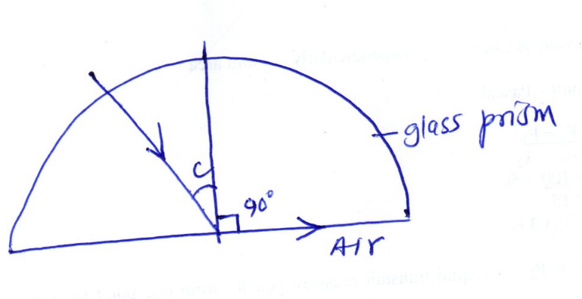

- a) The figure below shows a displacement-position graph of a slinky spring as it is continuously vibrated at one end.
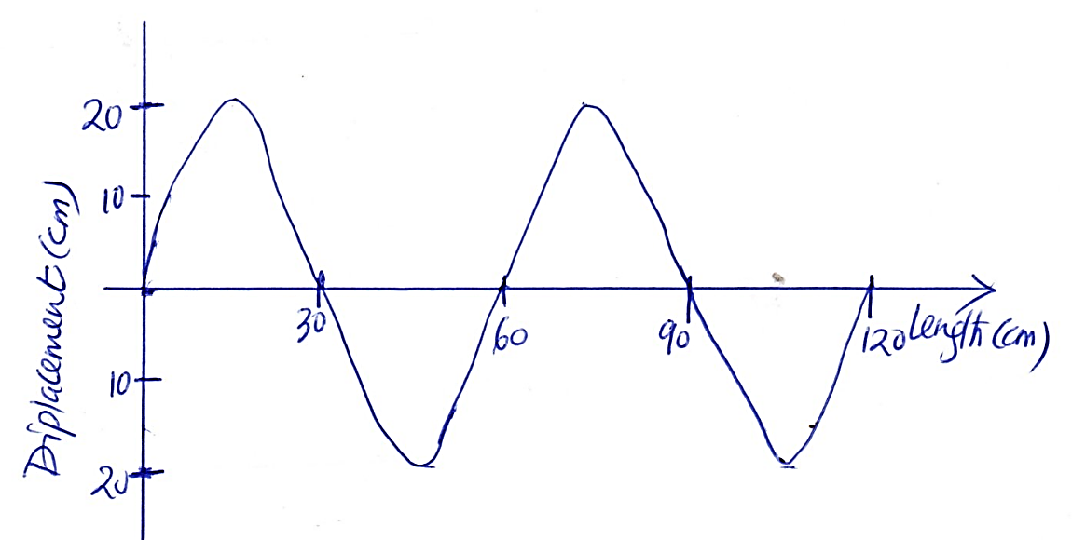
- Name the type of wave generated (1mk)

- Determine the amplitude of the wave (1mk)

- on the wave in c above and draw a wave showing the wave when the frequency is doubled (2mks)

(c) The figure 14 below shows a tuning fork producing sound waves of frequency 512 Hz.
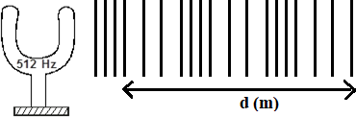

If the speed of sound in air is 330ms⁻¹. Determine the value of d. [3 marks]

- (a) A body moves 3000 meters due east in 40s then 4,000 due north in 60s. calculate;
- Its average speed (2mks)

- Its average velocity for the whole journey (2mks)

.
- A ball is thrown from the top of cliff 40m height with a horizontal velocity of 20m/s calculate:
- The time taken by the ball to strike the ground.(2mks)

- The distance from the foot of the cliff to where the ball strikes the ground.(2mks)

- The vertical velocity at the time it strikes the ground (take g = 10mls2)(2mks)

- Define pressure and give its S.I nits. (2mks)
…………………………………………………………………………………………………….
…………………………………………………………………………………………………….

(b) The diagram below represents a motor car hydraulic braking system;

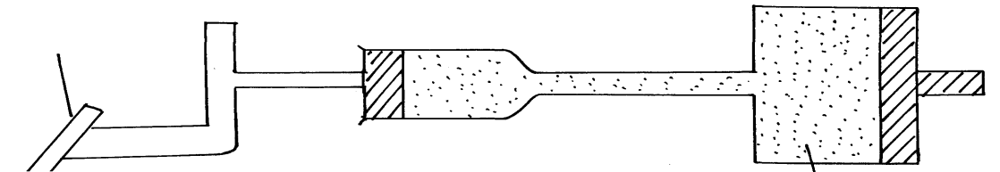
Brake pedal
Master piston
Slave piston brake fluid
B
A

- State two properties of the liquid used as a brake fluid (2mks)
……………………………………………………………………………………………………..………………………………………………………………………………………………………………………………………………………….…………………………………………………………………
- Given that in the diagram (b) above the master piston has an area of 15cm² and the slave piston has an area of 50cm² a force of 100N is applied on the master piston. Find the force used to stop the car. (3mks)

(c)Compare the values of pressure in the two pistons above and give a reason for your
answer. (2mks)

(d) Give a reason why gas is not suitable for use in place of the brake fluid. (1mk)

- (a) State the law of conservation of linear momentum (1mk)

(b) A lorry has a mass of 10,000kg initially travelling at a velocity of 10MS⁻¹ collides with a car of mass 2000kg travelling in the opposite direction at a velocity 20MS⁻¹. The two vehicles move together after impact through a distance of 20m before coming to rest.
(i) Determine the acceleration of the system after the collision (4mks)

- What is the impulsive force on the car given the collision lasts two seconds (3mks)

- (a)Sound is a mechanical longitudinal wave. Explain why sound is classified as;
- A mechanical wave. (1 mark)

- A longitudinal wave. (1 mark)

b) The diagram below shows a set up that was used to demonstrate that, sound is a mechanical wave.

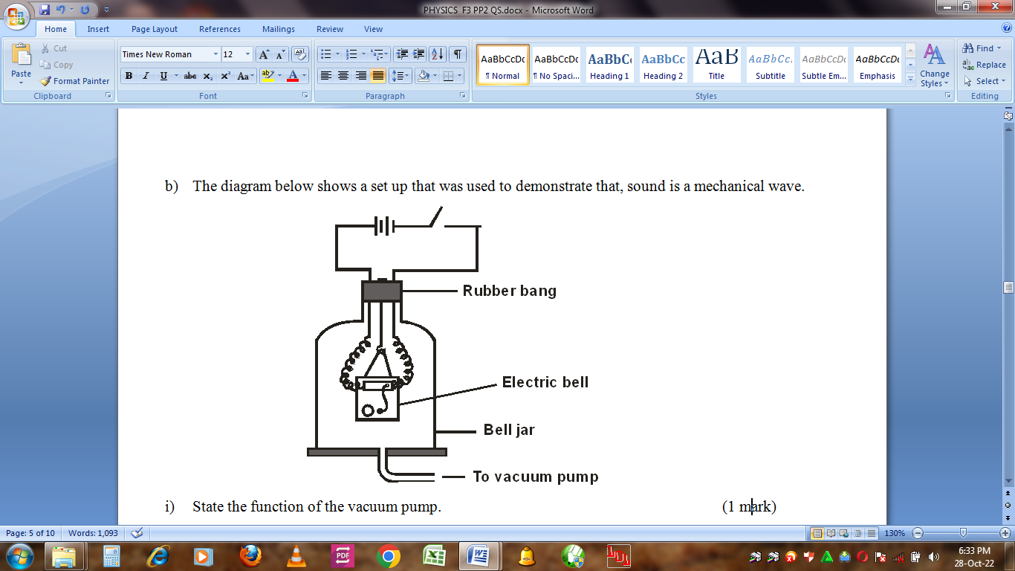
- State the function of the vacuum pump. (1 mark)

- When the switch is closed, state and explain what happens as the air is continuously drawn from the bell jar. (3 marks)

- State two possible reasons why it is not possible to reduce the sound completely in this experiment. (2 marks)

c) A fishing boat uses ultrasound to detect fish directly below. Two echoes of the ultrasound are received, one after 0.09 seconds coming from the shoal of fish and the other after 0.12 seconds coming from the sea bed. The sea bed is 84m below the ultrasound transceiver.
- State one reason why ultrasound is preferred. (1 mark)

- Calculate the speed of the ultrasound waves in water. (3 marks)

