Paper 2 MARKING SCHEME
section A

- Two magnets A and B in the figure below were brought from a point high above a table towards a steel pin.
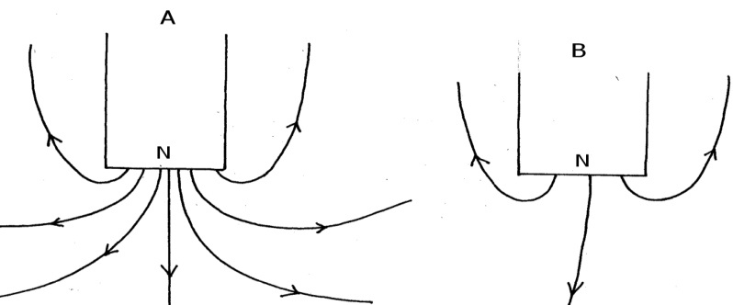
State with reason which magnet will attract the pin at a bigger height above the table. (2mks)
A . Has strong magnetic field
2.(a) The figure below shows container loader which uses electromagnet to offload containers from a ship.

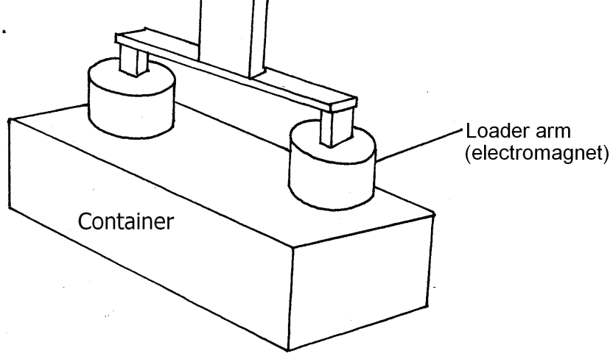
(i) Why should the container be made of iron or steel (1mk)
Iron and steel can be attracted by magnets
(ii) State two ways in which the loader can be made to lift heavier container (2mks)
-increasing size of current
- increasing the number of load arms (electromagnets)

(b) The figure below shows an arrow indicating the direction of a current in conductor.

Card board

conductor
Sketch on the diagram the magnetic field pattern due to the current. (2 mks)

3. A current of 0.5A flows in a circuit. Determine the quantity of charge that crosses a point in 4 minutes . (3mks)

Q= It
0.5 x 4 x 60
120C

4. The figure 3 shows a ray of light incident on a mirror.
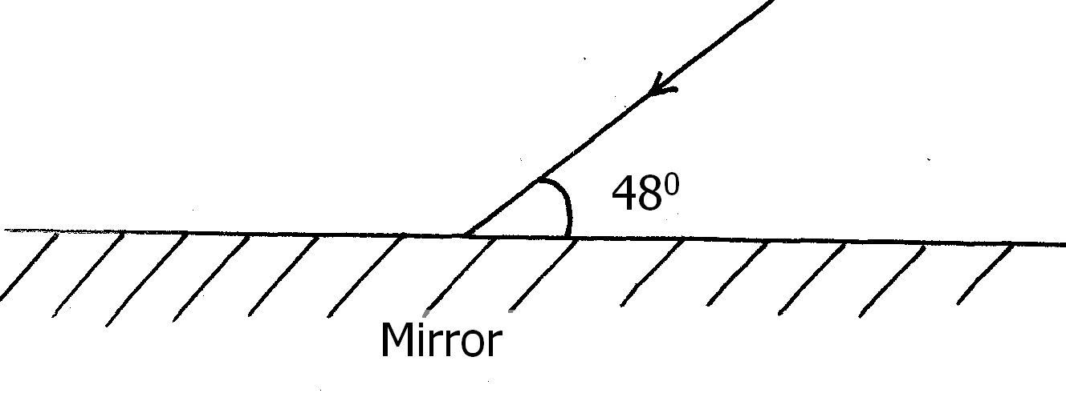
Determine the angle of reflection when the mirror is rotated 10⁰ anticlockwise (2mks)
$\frac{84+20}{2}$ = 52
5. Two 12V lead acid accumulators are rated 60Ah and 70Ah. State two physical differences between the accumulators (2mks),
60Ah | 70Ah
Small size/area of lead plates | Large surface area of lead plates
Few number of plates | High number of plates

- A wave with a periodic time of 0.2 seconds is travelling at a speed of 50cms⁻¹. What is the wavelength of the wave? (3 mks)
V = $\frac{ℷ}{T}$
ℷ= 50 X 0.2 = 10 Cm

- State one advantage and one disadvantage of a convex mirror when used as a driving mirror. (2 mks)
Advantage:
Give a wide field of view

Disadvantage:
The image is diminished making hard for driver to judge distances

- A girl holds a large concave mirror of focal length 1m, at a distance of 80 cm from her face. State two characteristics of her image in the mirror. (2 mks
- Virtual
- Magnified
- erect

- The chart below shows an arrangement of different parts of the electromagnetic spectrum.
Radio wave | A | Infrared rays | B | Ultra-violet | χ-Rays
Name the radiation represented by
A - michrowave (1mark)
State one use of radiation represented by B (1mark)
vision

- The figure below shows part of electric cooker coil.
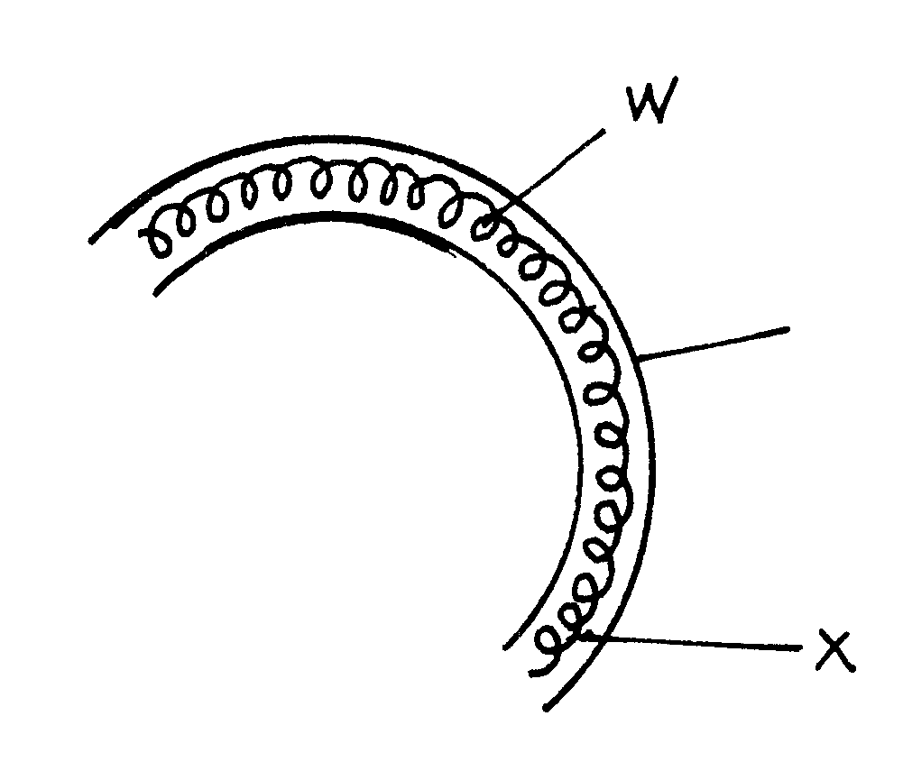
y

- Why is the material labeled Y coiled? (1mk)

Increasing the length increases the resistance of the heating element

- State the property of material Y that makes it suitable for its use. (1mk)

High melting point

SECTION B (55 Marks)
MARKING SCHEME
- a)State the law of electrostatic charges (1mks)
Like charges repel unlike charges attract.
b)The figure below shows a highly positively charged rod being brought slowly near the cap of a negatively charged gold leaf electroscope. It is observed that the leaf initially falls then rises.
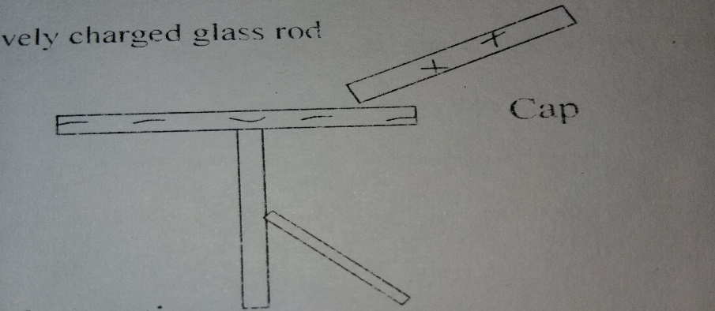
Explain the observation (1 mk)
- Leaf falls due to the positive charge attracting negative charge on electroscope making it neutral. When moved close, attract electrons making electroscope +vely charged hence divergence.
c) (i)The figure below shows an electric circuit used to charge a capacitor C. When switch is closed ,it is observed that the millimetre records some current which gradually reduces to zero with time
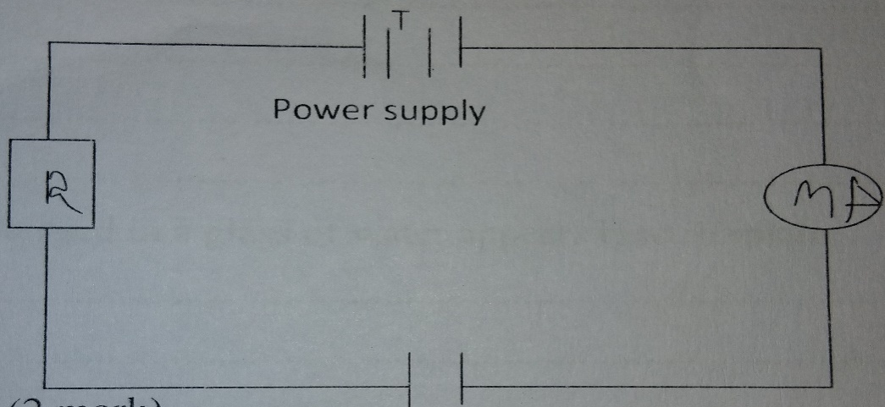

Explain the observation (2mks)
During charging MA records current at the same pd when capacitor is fully charged it reduces to zero.
(ii)State one factor that reduces the capacitance of a parallel plate capacitor (1mks)
- Increasing distance of separation
- Reducing area of overlap
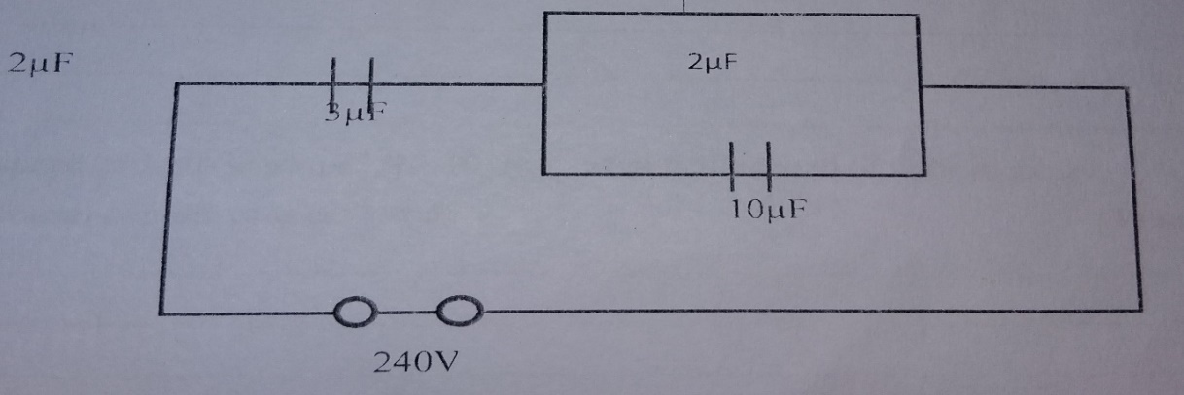
d)The figure shows an electrical circuit with three capacitors of 10µF,2µF and 3µF capacitance connected to a 240V supply.
Determine:
- The effective capacitance of the capacitor combination (2mks)

10 +2 =12
$\frac{1}{G}$ = $\frac{1}{12}$ + $\frac{1}{3}$ = CT = 2.4µf

(ii) The charge stored in the circuit (2mks)
Q = cv
= 2.4 x 10⁻⁶ x 240 = 5.76 x 10⁻⁴C

(iii) The potential difference across the 2µF capacitor (2mks)
v = $\frac{Q}{C}$ = 192
pd = 240 – 192 = 48V

- (a) A spoon partially submerged in a glass of water appears bent. Explain(1mks)
Refraction = glass optically denser than air
(b)A coin placed at the bottom of a tall gas jar.Whenthe jar is filled with paraffin to a depth of 32.4 cm, the coin is apparently seen displaced 9.9 cm from the bottom. What is the refractive index of paraffin? (3mks)
App. depth = 32.4 – 99 = 22.5cm
ɲ= $\frac{Real depth}{apparent depth}$ = $\frac{32.4}{22.5}$= 1.44
(c)State two conditions necessary for total internal reflection (2mks)
-Light from optically dense medium to less dense.
-Angle of incidence greater than critical angle
(d)The speed of light in air is 3.0×10⁸ m/s. What is the speed of light in glass? (3mks)
(Take refractive index of glass=1.5)
ɲ = $\frac{Va}{Vg}$ 1.5 = 3.0 x 10⁸
= 2^{v}.0 x 10⁸ms⁻¹
(e)State Snell’s law (1mk)
Ratio of sine of angle of incidence to ngle of refraction is a constant for a given pair of media.
- (a) State Lenz’s law (1mk)
The induced current is in such a direction to oppose the charge producing it.
b)The figure below shows two circuits close to each other
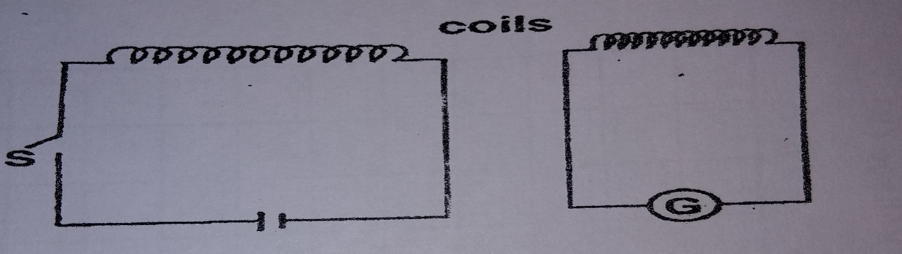

(i)State the observation made on the galvanometer when the switch is closed(1mks)
Galoanometer deflects their goes back to zero
(ii)Explain the observation (1mks)
Change infield in the coil causesa field change in the second coil causing an induced current in the second coil
(iii)Give one adjustment that can be done to the arrangement so that:
I)The galvanometer gives bigger deflection in the same direction (1mk)
2nd coil wound on top of coil 1
Add soft iron core
II)The galvanometer deflects in the opposite direction (1mk)
Change polanty of the cells
c)In a transformer, a voltage of 240V is to be stepped down to 24V. The primary current is found to be 1.5A while the secondary current is 14A. Calculate:
i)Power output (2mks)
V_{p} = 240v I_{p} = 1.5A
v_{s} = 24v I_{s} = 14A
P_{o} = vs x Is = 24 x 14 = 336w
ii)Power input (1mks)
P₁ = V_{p} x I_{p}
= 240 x 1.5
= 360W
iii)Efficiency of the transformer(2mks)
E_{ﬀ} = P_{o} x 100% 336 x 100% = 93.33%
P₁ 360
iv)State one way in which the power in a transformer is lost (1mks)
- Eddy current
- copper losses
- hysterists loss
14. a) State one condition under which ohms law is obeyed in a metal conductor (1mk)
- Constraint temperature

b)You are provided with three resistors R1, R2, R3 connected in parallel. If the p.d across them is V, show that an expression for the effective resistance of the three resistors is given by. $\frac{1}{Rt}$=$\frac{1}{R1}$+$\frac{1}{R2}$+$\frac{1}{R3}$ (3mks)
I₁ = I₁ + I₂ + I₃
but V constant
VR = V₂ = V₁ = V₃
V = IR I = $\frac{V}{R}$
$\frac{V}{RT}$ = $\frac{V}{R}$ + $\frac{V}{R2}$ + $\frac{V}{R3}$
$\frac{V}{RT}$ = V $\frac{1}{R1}$ + $\frac{1}{R2}$ + $\frac{1}{R3}$
$\frac{1}{RT}$ = $\frac{1}{R1}$ + $\frac{1}{R2}$ + $\frac{1}{R3}$

c) The figure below shows three resistors as shown
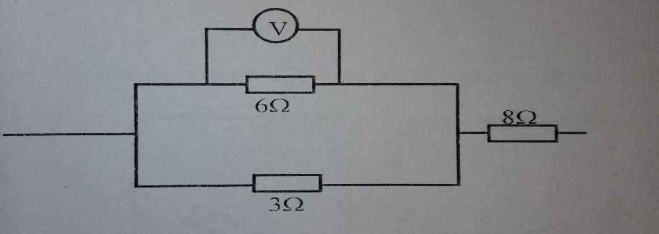
If the voltmeter reads 4V, find the
i)Effective resistance (2mks)
$$\frac{1}{RT1}=\frac{1 }{6}+\frac{1 }{3}=\frac{1+2 }{6}=\frac{3}{6}$$

RT = 2 + 8
= 10Ω

ii)Current through the 3Ω resistor (3 mks)
$\frac{V}{R}$ = $\frac{4}{3}$ = 1.333A
iii)Potential difference across the 8Ω resistor if the total voltage in the circuit is 10V (1mk)
V = 10 – 4
= 6v
d)draw a circuit diagram showing three bulbs A,B and C, an ammeter and a 12V supply connected in such a way that they operate at same potential and all light with equal brightness (2mks)
all bulbs in parallel and ammeter in series

- a) State the difference between progressive waves and standing waves (2mks)
Standing, waves formed when two equal progressive waves partially in opposite direction interfere with each other while progressive waves are waves which move continuously away from the source.

b) Sketch a graph of displacement against time for a transverse wave of frequency 50 Hz with at least two cycles with amplitude of 2cm (2mks)

2

s (cm)
0.02 0.04
time (s)
-2

c)The figure shows an experiment to observe interference of light waves . Waves are incident to double slits closed t a source of monochromatic light.
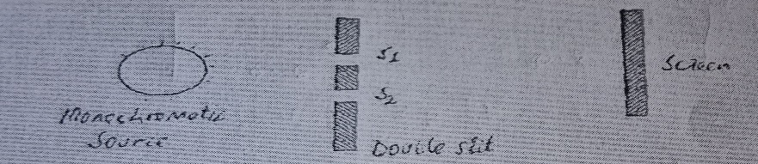
i)State what is meant by a monochromatic source of light (1mk)
Source producing one colour of light
ii)State the function of the double slit (1mk)
To produce coherent sources
iii)State and explain what is observed on the screen (3mks)
- Alternating dark and bright fringes
- Bright – constructive
- Dark - destructive
iv)state what is observed on the screen when the slit separation S1 and S2 is reduced (1mk)
Separation of fringes decreases
v)White light is used in place of monochromatic source (1mk)
Coloured finges will be observed.

