NAME: ………………………………………………..…CLASS:….…ADM NO:…………
SIGNATURE:…………………………………
DATE…………………………………………
232/2
Physics
FORM 4
PAPER 2
TERM 1 2026

Instructions to candidates

- This paper consists of two sections A and B.
- Answer all the questions in the two sections in the spaces provided after each question
- All working must be clearly shown.
- Electronic calculators and Mathematical tables may be used.
- All numerical answers should be expressed in the decimal notations.

For Examiner use only
SECTION | CANDIDATE’S SCORE
A (25MKS)
B(55MKS)
TOTAL

Paper 2 section A

- Two magnets A and B in the figure below were brought from a point high above a table towards a steel pin.
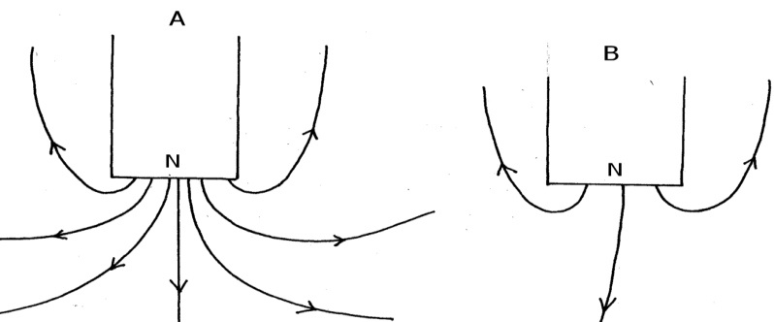
State with reason which magnet will attract the pin at a bigger height above the table. (2mks)
…………………………………………………………………………………………………………………………………………………………................……………………………………………………

2.(a) The figure below shows container loader which uses electromagnet to offload containers from a ship.

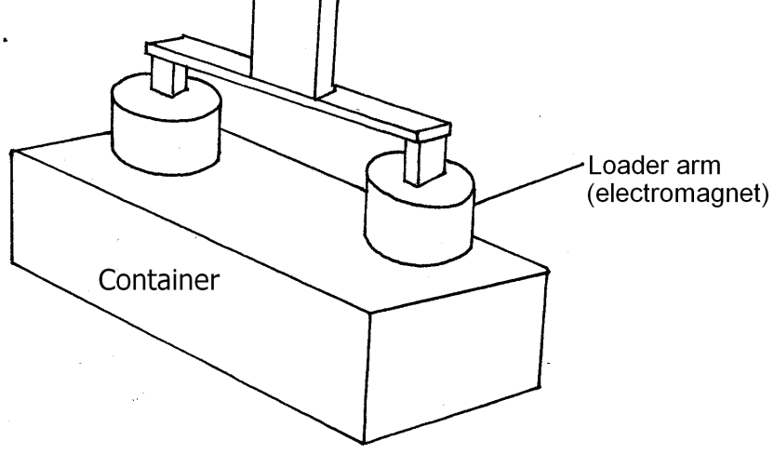
(i) Why should the container be made of iron or steel (1mk)
………………………………………………………………………………………………………………………………………………………………………………………………………………
(ii) State two ways in which the loader can be made to lift heavier container (2mks)
………………………………………………………………………………………………………………………………………………………………………………………………………………................
(b) The figure below shows an arrow indicating the direction of a current in conductor.

Card board

conductor
Sketch on the diagram the magnetic field pattern due to the current. (2 mks)

3. A current of 0.5A flows in a circuit. Determine the quantity of charge that crosses a point in 4 minutes . (3mks)

4. The figure 3 shows a ray of light incident on a mirror.
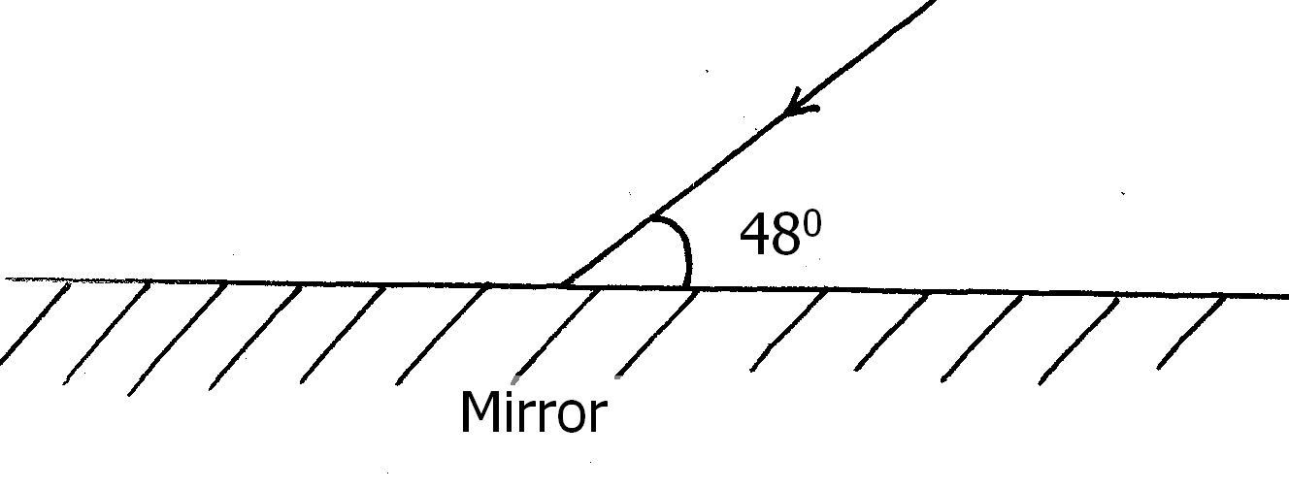
Determine the angle of reflection when the mirror is rotated 10⁰ anticlockwise (2mks)
5. Two 12V lead acid accumulators are rated 60Ah and 70Ah. State two physical differences between the accumulators (2mks)

- A wave with a periodic time of 0.2 seconds is travelling at a speed of 50cms⁻¹. What is the wavelength of the wave? (3 mks)

- State one advantage and one disadvantage of a convex mirror when used as a driving mirror. (2 mks)
Advantage:

Disadvantage:

- A girl holds a large concave mirror of focal length 1m, at a distance of 80 cm from her face. State two characteristics of her image in the mirror. (2 mks

- The chart below shows an arrangement of different parts of the electromagnetic spectrum.
Radio wave | A | Infrared rays | B | Ultra-violet | χ-Rays
Name the radiation represented by
A …………………………………………………………. (1mark)
State one use of radiation represented by B (1mark)
…………………………………………………………………………………………………………………………………………………………………………………………………………………….……

- The figure below shows part of electric cooker coil.
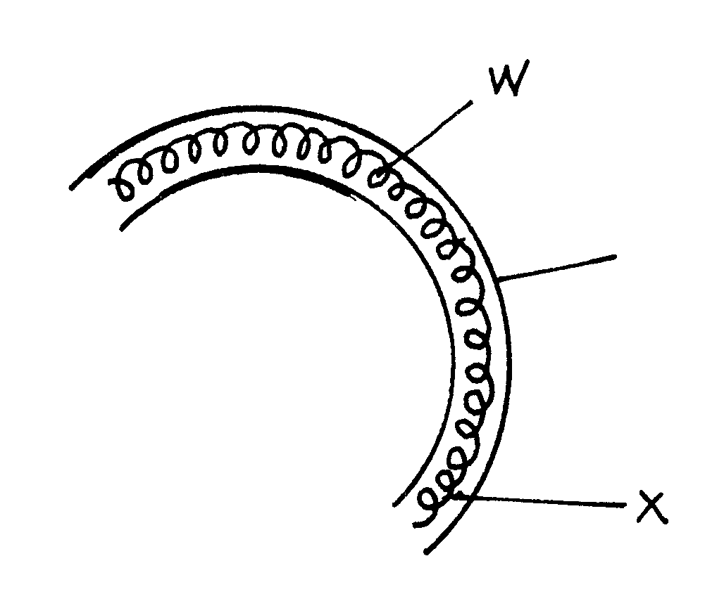
y

- Why is the material labeled Y coiled? (1mk)
…………………………………………………………………………………………………………………
- State the property of material Y that makes it suitable for its use. (1mk)
……………………………………………………………………………………………………………………………………………………………………………………………………………………………………

SECTION B (55 Marks)

- a)State the law of electrostatic charges (1mks)

b) The figure below shows a highly positively charged rod being brought slowly near the cap of a negatively charged gold leaf electroscope. It is observed that the leaf initially falls then rises.
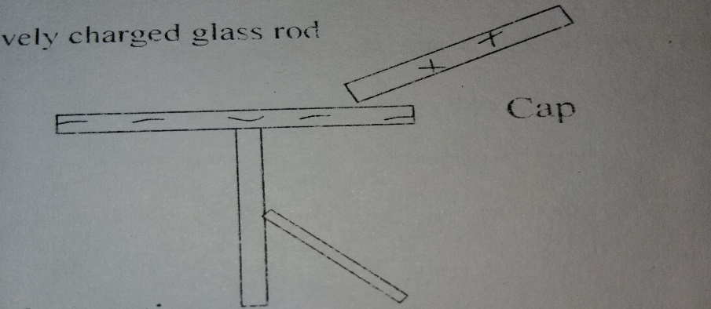
Explain the observation (1 mk)

c) (i)The figure below shows an electric circuit used to charge a capacitor C. When switch is closed ,it is observed that the millimetre records some current which gradually reduces to zero with time
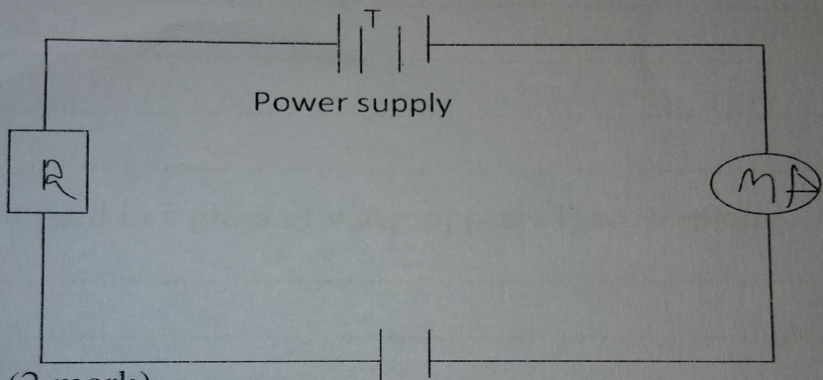
Explain the observation (2mks)

(ii)State one factor that reduces the capacitance of a parallel plate capacitor (1mks)

d)The figure shows an electrical circuit with three capacitors of 10µF, 2µF and 3µF capacitance connected to a 240V supply.
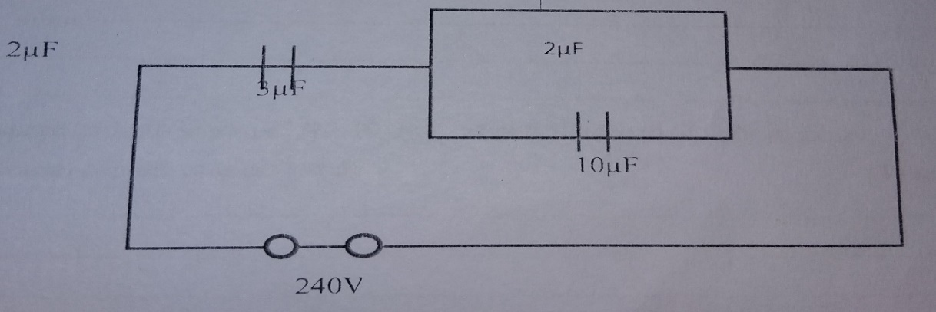

Determine:
(i) The effective capacitance of the capacitor combination (2mks)

(ii) The charge stored in the circuit (2mks)

(iii) The potential difference across the 2µF capacitor (2mks)

- (a) A spoon partially submerged in a glass of water appears bent. Explain(1mks)

(b)A coin placed at the bottom of a tall gas jar. When the jar is filled with paraffin to a depth of 32.4 cm, the coin is apparently seen displaced 9.9 cm from the bottom. What is the refractive index of paraffin? (3mks)

(c)State two conditions necessary for total internal reflection (2mks)

(d)The speed of light in air is 3.0×10⁸ m/s. What is the speed of light in glass? (3mks)
(Take refractive index of glass=1.5)

(e)State Snell’s law (1mk)

- (a) State Lenz’s law (1mk)

b) The figure below shows two circuits close to each other
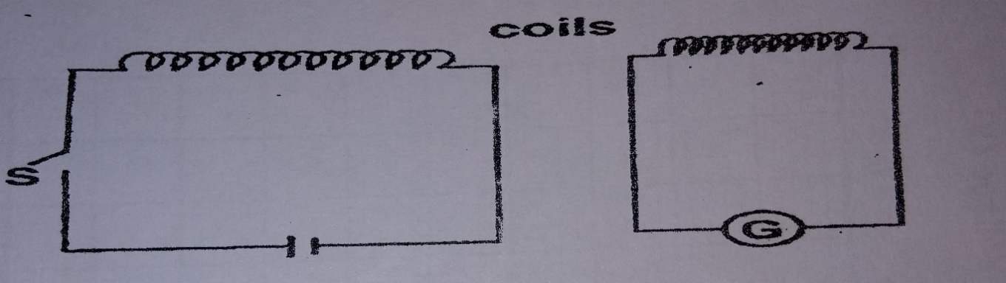

(i)State the observation made on the galvanometer when the switch is closed (1mks)

(ii)Explain the observation (1mks)

(iii)Give one adjustment that can be done to the arrangement so that:
I)The galvanometer gives bigger deflection in the same direction (1mk)

II)The galvanometer deflects in the opposite direction (1mk)

c)In a transformer, a voltage of 240V is to be stepped down to 24V. The primary current is found to be 1.5A while the secondary current is 14A. Calculate:
i)Power output (2mks)

ii)Power input (1mks)

iii)Efficiency of the transformer(2mks)

iv)State one way in which the power in a transformer is lost (1mks)

- a) State one condition under which ohms law is obeyed in a metal conductor (1mk)

b)You are provided with three resistors R1, R2, R3 connected in parallel. If the p.d across them is V, show that an expression for the effective resistance of the three resistors is given by. $\frac{1}{Rt}$=$\frac{1}{R1}$+$\frac{1}{R2}$+$\frac{1}{R3}$ (3mks)

c) The figure below shows three resistors as shown
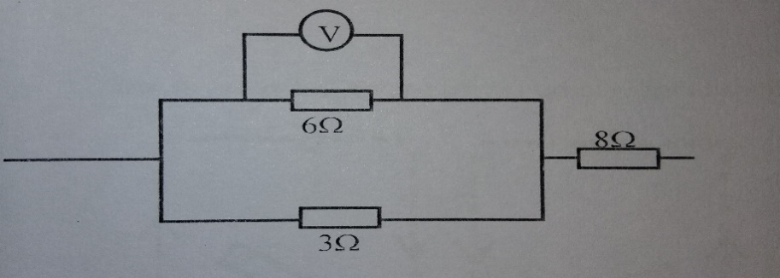
If the voltmeter reads 4V, find the
i)Effective resistance (2mks)

ii)Current through the 3Ω resistor (3 mks)

iii)Potential difference across the 8Ω resistor if the total voltage in the circuit is 10V (1mk)

d)draw a circuit diagram showing three bulbs A,B and C, an ammeter and a 12V supply connected in such a way that they operate at same potential and all light with equal brightness (2mks)

- a) State the difference between progressive waves and standing waves (2mks)

b)Sketch a graph of displaced against time for a transverse wave of frequency 50 Hz with at least two cycles with amplitude of 2cm (2mks)

c)The figure shows an experiment to observe interference of light waves . Waves are incident to double slits closed t a source of monochromatic light.
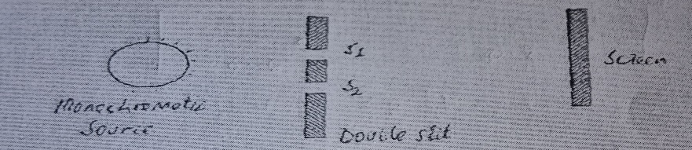
i)State what is meant by a monochromatic source of light (1mk)

ii)State the function of the double slit (1mk)

iii)State and explain what is observed on the screen (3mks)

iv)state what is observed on the screen when the slit separation S1 and S2 is reduced (1mk)

v)White light is used in place of monochromatic source (1mk)

