NAME: ………………………………………………..…CLASS:….…ADM NO:…………
SIGNATURE:…………………………………
DATE…………………………………………
232/3
Physics
FORM 4
PAPER 3 marking scheme
TERM 1 2026

Instructions to candidates

- This paper consists of two sections A and B.
- Answer all the questions in the two sections in the spaces provided after each question
- All working must be clearly shown.
- Electronic calculators and Mathematical tables may be used.
- All numerical answers should be expressed in the decimal notations.

For Examiner use only
SECTION | CANDIDATE’S SCORE
A (20MKS)
B (20MKS)
TOTAL

QUESTION 1
You are provided with the following;
  - A candle
  - A white screen
  - A metre rule
  - A lens
  - A lens holder
  - A piece of plasticine.

Proceed as follows:
- Arrange the apparatus as shown below.

Screen
Light from a distant object

Metre rule
d
- Adjust the distance of the lens from the screen until a well-focused image of a very distant object like a tree, is seen on the screen. Record the distance between the screen and the lens as d.
d | = | 12.5 cm | (1 mark)
d | = | 0.125 m | (1 mark)
- Now place the lens at the midpoint of the metre rule.
(It will remain at this point throughout the entire experiment) Arrange the screen and lit candle as shown below.
Screen

Lens
Candle
y
d
d
x
C A 50cm B D
Mark the point A and B each of which is distance d (obtained in part b above) from the lens

- Place the lit candle at point D, 30cm from B. Adjust the position of the screen until a sharp image appears on it. The screen is at C. Measure BD and AC and record them as x and y respectively in the table below.

BD= X cm | AC= y cm | $\frac{1}{y}$ cm⁻¹
30 | 2.2 | Candidate’s values  All correct 1mk
25 | 3.8 | Candidate’s values  All correct 1mk
20 | 5.5 | Candidate’s values  All correct 1mk
15 | 9.2 | Candidate’s values  All correct 1mk
10 | 17.0 | Candidate’s values  All correct 1mk
₊^{- 0.5}each 1mk max 5mks

- Repeat the procedure in (d) above for other values of x in the table and complete it. (6 marks)
- i) Draw a graph ¹ (y-axis) against x. (5 marks)
𝑦

Labelling axis – 1mkt

Scale 1mk

Plotting 2mks

Straight line with positive gradient passing at least 3 correctly plotted points 1mk
  - Determine the slope S of the graph. (3 marks)

Substituded values from two points read from the graph/line 1mk

Working 1mk
Answer with units 1mk

  - Calculate the value of m given that

m = √1
𝑠

Substitution 1mk
Correct answer with units 1mk

(2 marks)

  - Comment on values of m and d. (2 marks)

M = magnification
d= focal length

QUESTION 2

You are provided with the following apparatus

- Two new dry cells
- A resistor of 10Ω labeled Q
- Wire mounted on a millimeter scale (G28)
- 6 connecting wires with crocodile clips on one end of at least three
- A voltmeter
- An ammeter
- A switch

Proceed as Follows:

- Connect the apparatus provided as shown in figure below

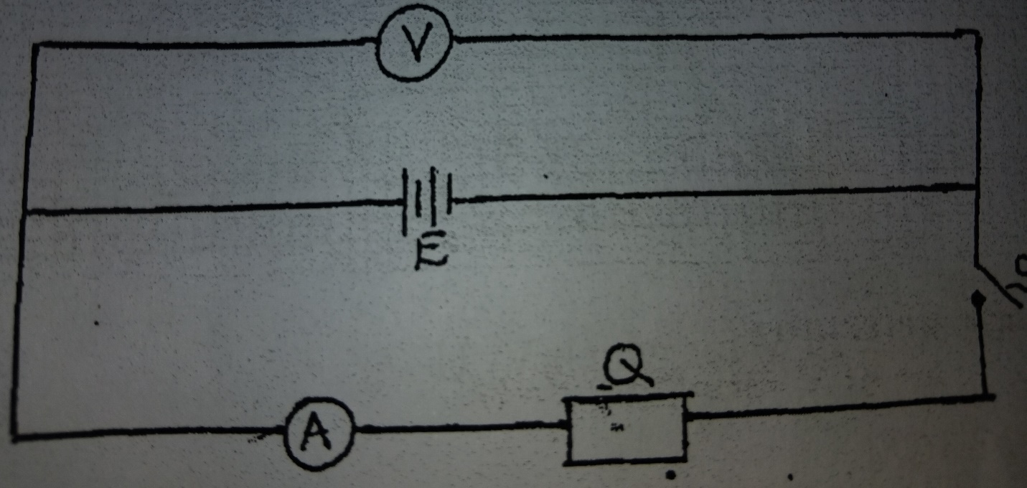

- Take the voltmeter reading when the switch S is open

V₁ = ……3.0…-⁺…0.1…………………. volts (1mk)

- Close the switch S, and take the voltmeter reading V₂ and the ammeter reading I

V₂ =2.8 -⁺ 0.1volts (1 mk)

I = 1.8 ₋⁺ 0.1 Amperes (1 mk)

- Calculate the quantity P = V₁ – V₂ (2mks)

I

P= 3.0-2.8
1.8
=0.1111 Ω

- Set up the circuit as shown in figure below.

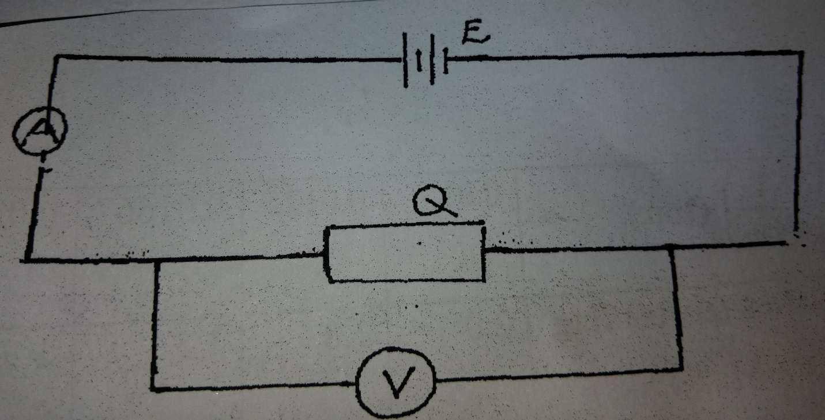

- Take the voltmeter reading V and the ammeter reading I (2mks)

V= 2.5 V

I = 0.20 ₋⁺ 0.02 A

- Determine the resistance R of Q given that (2mks)

R=V/I
=2.5/0.2 =12.5 Ω

- Set up the circuit shown in figure

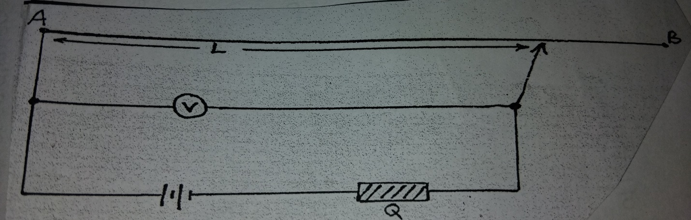

- Move the crocodile clip along the wire AB to a point such that L = 100cm
Note: the voltmeter reading and record in table 2.
e) Repeat (d) above for values of L = 80cm, 60cm, 40cm, 20cm and 0cm, tabulate your results. (6mks)
Length L  (cm) | 100 | 80 | 60 | 40 | 20
$\frac{1}{L}$ $\left(\frac{1}{cm }\right)$ 1(mk) | 0.01 | 0.0125 | 0.01667 | 0.025 | 0.05
Voltmeter Reading  (V) (Max 4mks) | 2.0 | 1.8 | 1.5 | 1.3 | 0.8
$\frac{1}{V}\left(\frac{1}{V }\right)$ (1mk) | CANDIDA | TES | VALUES

Note
V values + 0.1 @ 1mk
1/L and 1/V values All corret 1mk each

(e) Plot the graph of $\frac{1}{V}$ against $\frac{1}{L}$ 5mks

Axes 1mk
Scale Simple ,Uniform And accommodate all values 1 mk
Plotting accurate each ½ mk max 2mks
Line passing through 3 correctly plotted points 1 mk

- Find the slope of the graph. (2mks)
1.25-0.5
0.05 -0.01
= 18.75 cm/V

